
International
Moving Into Wholeness...
Forgiveness Day Festival
Sunday, August 3, 2003
1:00 p.m. – 4:30 p.m.
Keoni Room
Hawai’i Imin International Conference Center, East-West Center
1777 East-West Road, University of Hawai’i, Manoa

FEATURING:

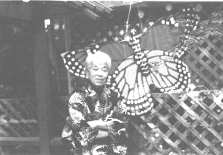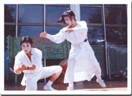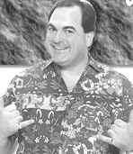
Takashi Tanemori, "Hibakusha" Survivor
of the Hiroshima Atomic Bomb,
Founder, Silkworm Peace Institute
Lafayette, California
Live Performance of "Takashi's Dream" by
Eth-Noh-Tec, Award-winning Story-Telling Movement Duet
from San Francisco, California
Frank DeLima, Entertainer & Founder,
Frank DeLima's School Enrichment Project

Explore the value & benefits of Forgiveness through Frank DeLima’s School Enrichment Project; Experience the dramatic power of Eth-Noh-Tec’s performance of “Takashi’s Dream”;
Listen to Takashi Tanemori share his amazing transformation from revenge to Forgiveness;
Know how Ho’oponopono - Hawai’i’s gift of Forgiveness – offers a path toward wholeness;
Learn about community projects/services related to Forgiveness…
Forgiveness Day Festival opens at 1:00 p.m. with displays, music & crafts/mural creation;
Program begins at 2:00 p.m.
Come & enjoy a memorable afternoon for the whole family!

For more information contact ph: 587-5712

FREE PARKING on UHM-Campus for this FREE EVENT!

Major funding for this event is provided by a grant from the Reverend Takie Okumura Fund of the Hawai’i Community Foundation. Presented by Conversation On Forgiveness For Youth (COFFY), Hawaii Center For Attitudinal Healing, Office of Youth Services, Casey Family Programs, Volunteer Resource Center, Hawaii Intergenerational Network, World Congress of Youth, Hawaii Foster Youth Coalition, Humanity United Globally, SuMoCaArts, Queen Lili’uokalani Children’s Center, Lanikai School, Outreach For Grieving Youth Alliance, and City & County of Honolulu Parks & Recreation Department.

