  Starting from: | 4130 Telegraph Ave, Oakland, CA 94609-2406
  Arriving at: | 1187 Franklin Street, San Francisco, CA 94109-6813
  Distance: | 11.7 miles | Approximate Travel Time: | 21 mins
  · Email Directions
  · Get Reverse Directions
  · Text Only Driving Directions

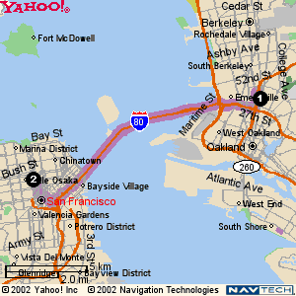  Full Route | 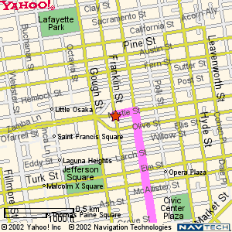  Destination

 | Directions | Miles
1. | Start on TELEGRAPH AVE | 0.0
2. | Turn Left on 42ND ST | 0.2
3. | Turn Right on MARTIN LUTHER KING JR WAY | 0.2
4. | Bear Right to take the CA-24 WEST ramp towards DOWNTOWN OAKLAND/HAYWARD/SAN FRANCISCO | 0.0
5. | Turn Right towards HAYWARD/SAN FRANCISCO | 0.3
6. | Continue on I-580 RAMP | 0.2
7. | Continue on I-580 WEST RAMP towards HAYWARD | 0.5
8. | Merge on I-580 WEST | 0.7
9. | Take the I-80 WEST exit towards SAN FRANCISCO | 0.6
10. | Merge on I-80 WEST | 7.2
11. | Take the NINTH STREET exit towards CIVIC CTR/GOLDEN GATE BR | 0.2
12. | Turn Left on HARRISON ST | 0.1
13. | Turn Right on 9TH ST | 0.5
14. | Turn Left on HAYES ST | 0.2
15. | Turn Right on VAN NESS AVE | 0.6
16. | Turn Left on GEARY BLVD | 0.1

