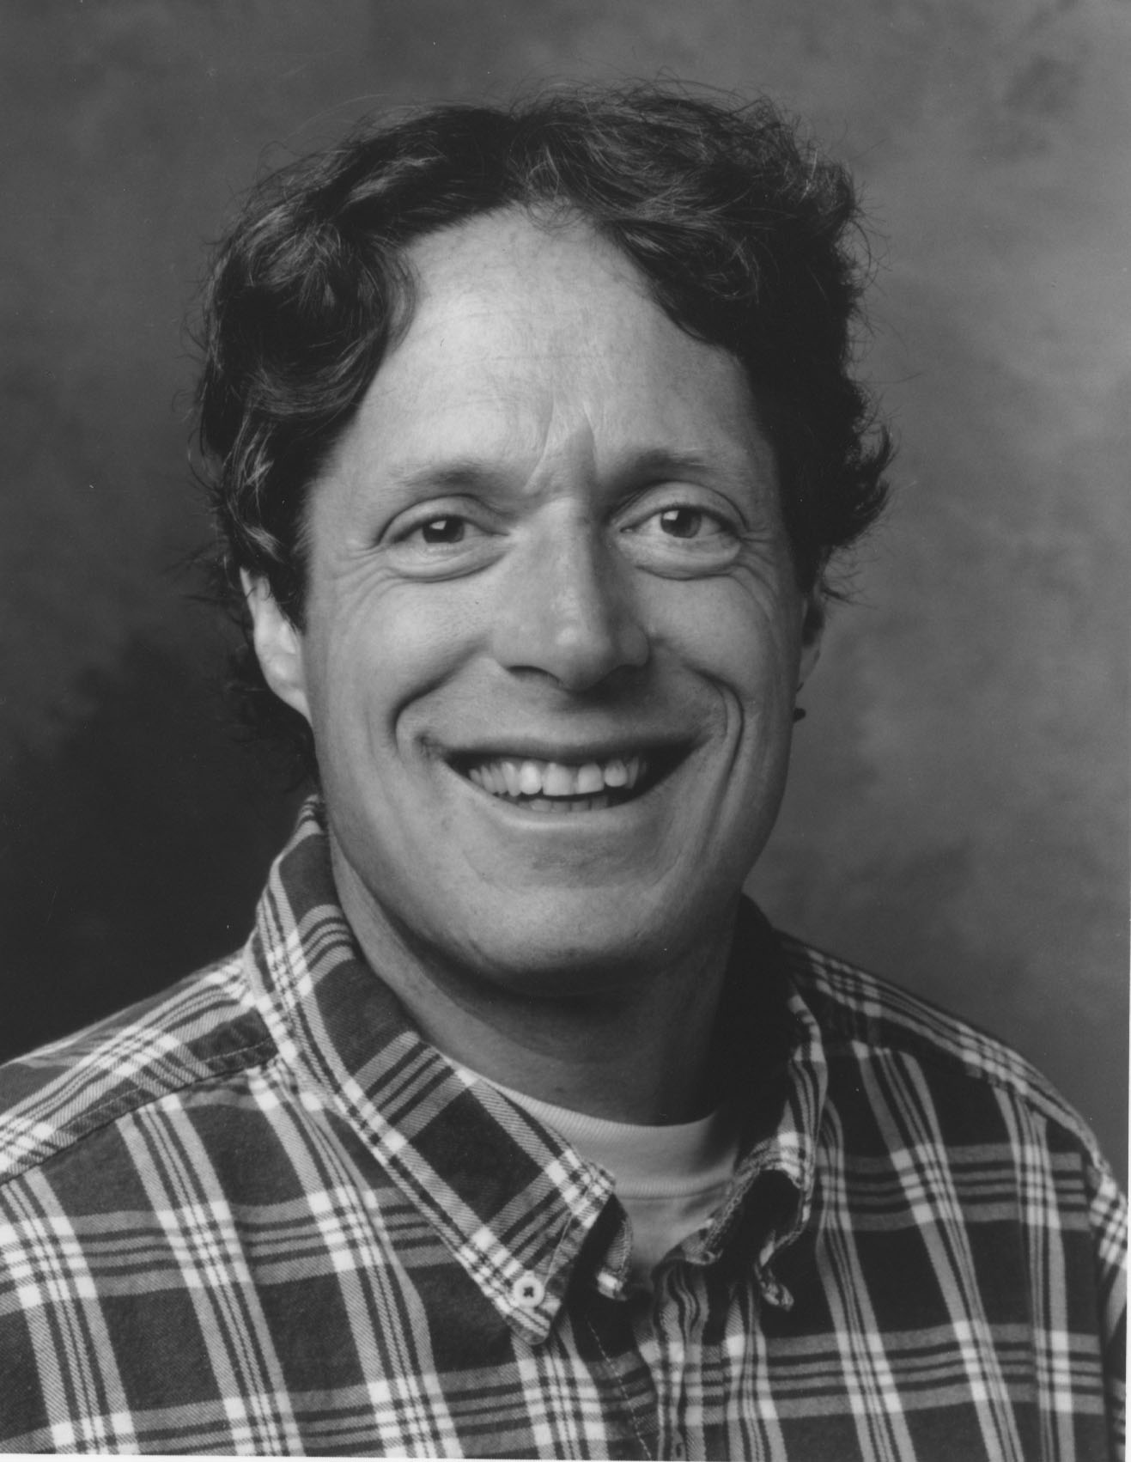
Worldwide Forgiveness Alliance
45 Camino Alto, Suite 200
Mill Valley, CA 94942

PRESS RELEASE

The world’s foremost expert on the subject of forgiveness — how it measurably improves emotional and physical well-being — will conduct a dynamic hands-on workshop on Saturday, March 9, 2002 from 10:00 a.m. to 5:00 p.m. at the West Berkeley Senior Center, Berkeley, California.

Dr. Frederic Luskin, Director of the Stanford University Forgiveness Project, has amassed the most important clinical study proving that holding onto resentment or hurt disrupts our personal and professional lives, leads to poor decision-making, and releases stress chemicals that can negatively impact personal health. Dr. Luskin will offer startling new insights into the healing power of forgiveness and will provide the tools to learn how to forgive for a better, happier, more hopeful long-lasting life.

“All too many of us clutch our grievances and give away our power,” he says, “by remaining victims of the people who have hurt us.”

Dr. Luskin will also have and sign copies of his new book Forgive for Good, hot off the presses of Harper Press (San Francisco), which received accolades from Dr. Gerald Jampolsky, Rabbi Harold S. Kushner, and Dr. John Gray.

The workshop will be held at the West Berkeley Senior Center at 1900 Sixth Street, Berkeley. Cost is $75, $50 for seniors and students. Limited scholarships are available.

For more information:

Bob Plath, Worldwide Forgiveness Alliance, 415-381-3372

