FASTIICIVIPAMT
APPRENTICE

REJECTS!
What They Did-and Didn't-
Learn From The Donald

»HOW SMART PEOPLE WORK
CHANGE
o R 13
What if you were given that choice?
For real. What if it weren't just the rhetoric that confuses
corporate performance with life or death, but actual life or
death? Yours. What if a doctor said you had to make tough
changes in the way you think and act—or your time would end
soon? Could you change? Here are the scientifically studied
odds: nine to one. That's nine to one against you. continued on, 52
$4.99 US $5.99 CANADA FASTCOMPANY.COM  111 11111 1111 IT r  • 5 ro _{t} 9 NJ _{ri}C If |  | << She's #1  Taryn Rose was a surgeon with

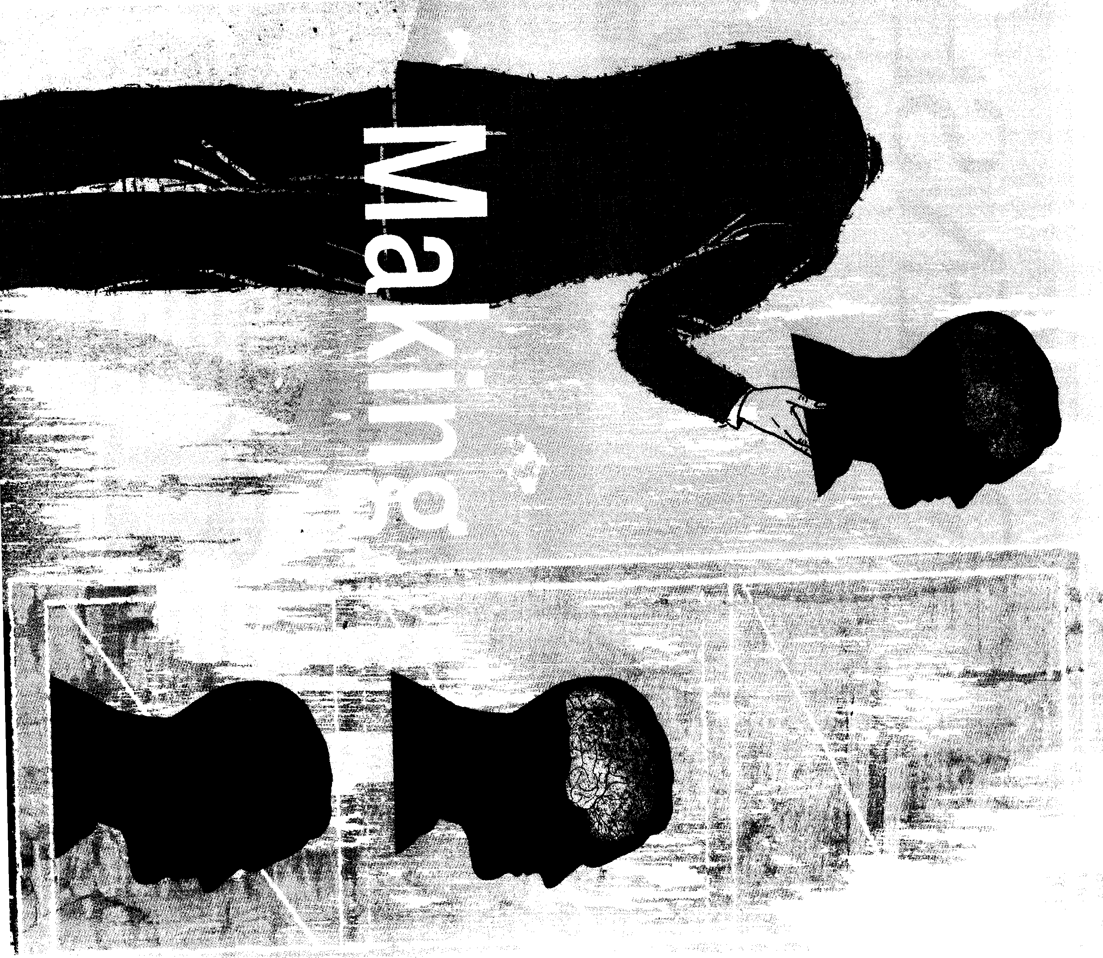
~.
~. a
By Alan Deutschman
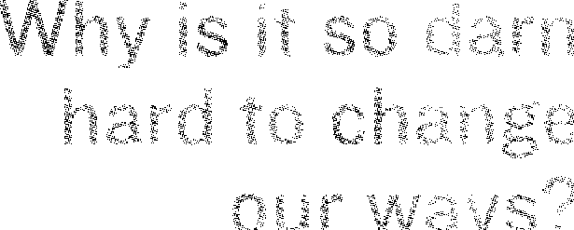

New insights from
psychology and
neuroscience offer
some surprising
answers—and
ways to improve
the odds.

This revelation unnerved many people in the audience last November at IBM's "Global Innovation Outlook" conference. The company's top executives had invited the most farsighted thinkers they knew from around the world to come together in New York and propose solutions to some really big problems. They started with the crisis in health care, an industry that consumes an astonishing $1.8 trillion a year in the United States alone, or 15% of gross domestic product. A dream team of experts took the stage, and you might have expected them to proclaim that breathtaking advances in science and technology—mapping the human genome and all that—held the long-awaited answers. That's not what they said. They said that the root cause of the health crisis hasn't changed for decades, and the medical establishment still couldn't figure out what to do about it.
What if you were given that choice? For real. What if it weren't just the hyperbolic rhetoric that conflates corporate performance with life and death? Not the overblown exhortations of a rabid boss, or a slick motivational speaker, or a self-dramatizing CEO. We're talking actual life or death now. Your own life or death. What if a well-informed, trusted authority figure said you had to make difficult and enduring changes in the way you think and act? if you didn't, your time would end soon—a lot sooner than it had to. Could you change when change really mattered? When it mattered most?
Yes, you say?
Try again.
Yes?
You're probably deluding yourself.
You wouldn't change.
Don't believe it? You want odds? Here are the odds, the scientifically studied odds: nine to one. That's nine to one against you. How do you like those odds?
Dr. Raphael "Ray" Levey, founder of the Global Medical Forum, an annual summit meeting of leaders from every constituency in the health system, told the audience, "A
90? ,1, of heart-bypass patient s cee , their lifestyles
even at the risk of dying,. No wonder
ehangiog people's behavior is the
toughest challenge in business:
tion consumes the vast majority of the health-care budget for diseases that are very well known and by and large behavioral." That is, they're sick because of how they choose to live their lives, not because of environmental or genetic factors beyond their control. Continued Levey: "Even as far back as when I was in medical school"—he enrolled at Harvard in 1955—"many articles demonstrated that 80% of the health-care budget was consumed by five behavioral issues." Levey didn't bother to name them, but you don't need an MD to guess what he was talking about: too much smoking, drinking, eating, and stress, and not enough exercise.
Then the knockout blow was delivered by Dr. Edward Miller, the dean of the medical school and CEO of the hospital at Johns Hopkins University. He turned the discussion to patients whose heart disease is so severe that they undergo bypass surgery, a traumatic and expensive procedure that can cost more than $100,000 if complications arise. About 600,000 people have bypasses every year in the United States, and 1.3 million heart patients have angioplasties—all at a total cost of around $30 billion. The procedures temporarily relieve chest pains but rarely prevent heart attacks or prolong lives. Around half of the time, the bypass grafts clog up in a few years; the angioplasties, in a few months. The causes of this so-called restenosis are complex. It's sometimes a reaction to the trauma of the surgery itself. But many patients could avoid the return of pain and the need to repeat the surgery—not to mention arrest the course of their disease before it kills them—by switching to healthier lifestyles. Yet very few do. "If you look at people after coronary-artery bypass grafting two years later, 90% of them have not changed their lifestyle," Miller said. "And that's been studied over and over and over again. And so we're missing some link in there. Even though they know they have a very bad disease and they know they should change their lifestyle, for whatever reason, they can't."
CRISIS IS A POWERFUL IMPETUS FOR CHANGE
, • Ninety percent of patients who've had coronary bypasses don't sustain changes in the unhealthy lifestyles that worsen their severe heart disease and greatly threaten their lives.
CHANGE IS MOTIVATED BY FEAR
It's too easy for people to go into denial of the bad things that might happen to them. Compelling, positive visions of the future are a much stronger inspiration for change.
THE FACTS WILL SET US FREE
Our thinking is guided by narratives, not facts. When a fact doesn't fit our conceptual "frames"—the metaphors we use to make sense of the world—we reject it. Also, change is in-
spired best by emotional appeals rather than factual statements.
SMALL, GRADUAL CHANGES ARE ALWAYS EASIER TO MAKE AND SUSTAIN
Radical, sweeping changes are often easier because they quickly yield benefits.
WE CAN'T CHANGE BECAUSE OUR BRAINS BECOME "HARDWIRED" EARLY IN LIFE
Our brains have extraordinary "plasticity," meaning that we can continue learning complex new things throughout our lives—assuming we remain truly active and engaged.

just the biggest challenge in health care. It's the most important challenge for businesses trying to compete in a turbulent world, says John Kotter, a Harvard Business School professor who has studied dozens of organizations in the midst of upheaval: "The central issue is never strategy, structure, culture, or systems. The core of the matter is always about changing the behavior of people." Those people maybe called upon to respond to profound upheavals in marketplace dynamics—the rise of a new global competitor, say, or a shift from a regulated to a deregulated environment—or to a corporate reorganization, merger, or entry into a new business. And as individuals, we may want to change our own styles of work—how we mentor subordinates, for example, or how we react to criticism. Yet more often than not, we can't.
CEOs are supposedly the prime changeas resistant to change as anyone—and as prone to backsliding. The most notorious recent example is Michael Eisner. After he nearly died from heart problems, Eisner finally heeded his wife's plea and brought in a high-profile number-two exec, Michael Ovitz, to alleviate the stress of running Disney. But Eisner proved incapable of seeing through the idea, essentiallyrefusing to share any real power with Ovitz from the start.
The conventional wisdom says that crisis is a powerful motivator for change. But severe heart disease is among the most serious of personal crises, and it doesn't motivate—at least not nearly enough. Nor does giving people accurate analyses and factual information about their situations. What works? Why, in general, is change so incredibly difficult for people? What is it about how our brains are wired that resists change so tenaciously? Why do we fight even what
Kotter has hit on a crucial insight. "Behavior change happens mostly by speaking to people's feelings," he says. "This is true even in organizations that are very focused on analysis and quantitative measurement, even among people who think of themselves as smart in an MBA sense. In highly successful change efforts, people find ways to help others see the problems or solutions in ways that influence emotions, not just thought."
Unfortunately, that kind of emotional persuasion isn't taught in business schools, and it doesn't come naturally to the technocrats who run things—the engineers, scientists, lawyers, doctors, accountants, and managers who pride themselves on disciplined, analytical thinking. There's compelling science behind the psychology of change—it draws on discoveries from emerging fields such as cognitive science, linguistics, and neuroscience—but its insights and techniques often seem paradoxical or irrational.

[FAST]TAKE

Which Stage of Change Are You In?
While studying how smokers quit the habit, Dr. James Prochaska, a psychologist at the
University of Rhode Island, developed a widely influential model of the "stages of change."
What stage are you in? See if any of the following statements sound familiar.

STAGE | RISKS

"As far as I'm concerned, I don't have any problems that need changing."
"I guess I have faults, but there's nothing that I really need to change."
"I've been thinking that I wanted to change something about myself."
"I wish I had more ideas on how to solve my problems."
"I have decided to make changes in the next two weeks."
"I am committed to join a fitness club by the end of the month."
"Anyone can talk about changing. I'm actually doing something about it."
"I am doing okay, but I wish I was more consistent."
{
PRECONTEMPLATION
("Never")
{
CONTEMPLATION
("Someday")
PREPARATION
("Soon")
{
{
ACTION ("Now")
You're in denial, dude. You probably feel
coerced by other people who are trying to
make you change. But they're not going to
shame you into it. Their meddling will backfire
Feeling righteous because of your good intentions, you could stay in this stage for years. But you might respond to the emotional persuasion of a compelling leader_
This "rehearsal" can become your reality
Some 85% of people who need to change
their behavior for health reasons never get
to this stage or progress beyond it.
It's an emotional struggle. It's important to change quickly enough to feel the short-
term benefits that give a psychic lift and
make it easier to stick with the change.

{ Relapse, Even though you've created a new mental pathway, the old pathway is still there in your brain, and when you're under a lot of stress, you might fall back on it.
"I may need a boost right now to help me maintain the changes I've already made."  "This has become part of my day and I feel it when I don't follow through." | MAINTENANCE  ("Forever")

ktatements" adapted from "Stages of Change: Theory and Practice," by Michael Samuelson, executive director of the National Center for Health Promotion

The best minds at Johns Hopkins and the Global Medical Forum might not know how to get them to change, but someone does: Dr. Dean Omish, a professor of medicine at the University of California at San Francisco and founder of the Preventative Medicine Research Institute, in Sausalito, California. Ornish, like Kotter, realizes the importance of going beyond the facts. "Providing health information is important but not always sufficient," he says. "We also need to bring in
dimensions that are so often ignored." Ornish published studies in leading peer-reviewed scientific journals, showing that his holistic program, focused around a vegetarian diet with less than 10% of the calories from fat, can actually reverse heart disease without surgery or drugs. Still, the medical establishment remained skeptical that people could sustain the lifestyle changes. In 1993, Ornish persuaded Mutual of Omaha to pay for a trial. Researchers took 333 patients
them quit smoking and go on Ornish's diet. The patients attended twice-weekly group support sessions led by a psychologist and took instruction in meditation, relaxation, yoga, and aerobic exercise. The program lasted for only a year. But after three years, the study found, 77% of the patients had stuck with their lifestyle changes—and safely avoided the bypass or angioplasty surgeries that they were eligible for under their insurance coverage. And Mutual of

Change
WHY DOES THE ORNISH PROGRAM succeed
while the conventional approach has failed? For starters, Ornish recasts the reasons for change. Doctors had been trying to motivate patients mainly with the fear of death, he says, and that simply wasn't working. For a few weeks after a heart attack, patients were scared enough to do whatever their doctors said. But death was just too frightening to think about, so their denial would return, and they'd go back to their old ways.
The patients lived the way they did as a day-to-day strategy for coping with their emotional troubles. "Telling people who are lonely and depressed that they're going to live longer if they quit smoking or change their diet and lifestyle is not that motivating," Ornish says. "Who wants to live longer when you're in chronic emotional pain?"
So instead of trying to motivate them with the "fear of dying," Ornish reframes the issue. He inspires anew vision of the "j oy of living"—convincing them they can feel better, not just live longer. That means enjoying the things that make daily life pleasurable, like making love or even taking long walks without the pain caused by their disease. "Joy is a more powerful motivator than fear," he says.
Pioneering research in cognitive science and linguistics has pointed to the paramount importance of framing. George Lakoff, a professor of those two disciplines at the University of California at Berkeley, defines frames as the "mental structures that shape the way we see the world." Lakoff says that frames are part of the "cognitive unconscious," but the way we know what our frames are, or evoke new ones, springs from language. For example, we typically think of a company as being like an army—everyone has a rank and a codified role in a hierarchical chain of command with orders coming down from high to low. Of course, that's only one way of organizing a group effort. If we had the frame of the company as a family or a commune, people would know very different ways of working together.
The big challenge in trying to change how people think is that their minds rely on frames, not facts. "Neuroscience tells us that each of the concepts we have—the long-
is instantiated in the synapses of the brain," Lakoff says. "Concepts are not things that can be changed just by someone telling us a fact. We may be presented with facts, but for us to make sense of them, they have to fit what is already in the synapses of the brain. Otherwise, facts go in and then they go right back out. They are not heard, or they are not accepted as facts, or they mystify us: Why would anyone have said that? Then we label the fact as irrational, crazy, or stupid." Lakoff says that's one reason why political conservatives and liberals each think that the other side is nuts. They don't understand each other because their brains are working within different frames.
The frame that dominates our thinking about how work should be organized—the military chain-of-command model—is extremely hard to break. When new employees start at W.L. Gore & Associates, the maker of Gore-Tex fabrics, they often refuse to believe that the company doesn't have a hierarchy with job titles and bosses. It just doesn't fit their frame. They can't accept it. It usually takes at least several months for new hires to begin to understand Gore's reframed notion of the workplace, which relies on self-directed employees making their own choices about joining one another in egalitarian small teams.
Getting people to exchange one frame for another is tough even when you're working one-on-one, but it's especially hard to do for large groups of people. Howard Gardner, a cognitive scientist, MacArthur Fellow "genius" award winner, and professor at Harvard's Graduate School of Education, has looked at what works most effectively for heads of state and corporate CEOs. "When one is addressing a diverse or heterogeneous audience," he says, "the story must be simple, easy to identify with, emotionally resonant, and evocative of positive experiences."
In Louis V. Gerstner Jr.'s successful turnaround of IBM in the 1990s, he learned the surprising importance of this kind of emotional persuasion. When he took over as CEO, Gerstner was fixated on what had worked for him throughout his career as a McKinsey & Co. consultant: coolheaded analysis and strategy. He thought he could revive the company through maneuvers such as selling assets and cutting costs. He quickly found that those tools weren't nearly enough. He needed to transform the
become hidebound and overly bureaucratic. That meant changing the attitudes and behaviors of hundreds of thousands of employees. In his memoir, Gerstner writes that he realized he needed to make a powerful emotional appeal to them, to "shake them out of their depressed stupor, remind them of who they were—you're IBM, damn it!" Rather than sitting in a corner office negotiating deals and analyzing spreadsheets, he needed to convey passion through thousands of hours of personal appearances. Gerstner, who's often brittle and imperious in private, nonetheless responded admirably to the challenge. He proved to be an engaging and emotional public speaker when he took his campaign to his huge workforce.
Steve Jobs's turnaround at Apple shows the impact of reframing and telling a new narrative that's simple, positive, and emotional. When he returned to the company after a long exile, he recast its image among employees and customers alike from a marginalized player vanquished in the battle for market share to the home of a small but enviable elite: the creative innovators who dared to "Think different."
When leaders are addressing a small group of people who have a similar mindset and shared values, the reframed message can be more nuanced and complex, Harvard's Gardner says. But it still needs to be
Frames are the mental structures
that define how we see the world. We
reject new facts that don't fit into
those structures. So to change behav-
ior, you have to change the frames.
positive, inspiring, and emotionally resonant. A good example is how chairman and publisher Arthur Sulzberger Jr. rescued The New York Times from crisis. Former editor Howell Raines had alienated much of the newsroom's staff, undermining its communal spirit with a new culture of favoritism. Raines fell when a star reporter he had shielded from criticism was exposed for f abricating news stories. The scandal threatened the famed paper's credibility. Gardner says that Sulzberger successfully reframed the narrative this way: We are a great newspaper. We temporarily went astray and risked sacrificing the community spirit that made this an outstanding place to work. We can retain our excellence and regain our sense of community by admitting our errors, making sure that they don't happen again, and being a more transparent and self-reflecting organization. To achieve these goals, Sulzberger replaced Raines with a new top editor, Bill Keller—a respected veteran who reflected the lost communal culture—and he appointed a "public editor" to critique the paper in an unedited column. Now, Gardner says, "the Times is a much happier place and the news coverage and journalistic empire are in reasonable shape."
Change
REFRAMING ALONE ISN'T ENOUGH, Of course.
That's where Dr. Ornish's other astonishing insight comes in. Paradoxically, he found that radical, sweeping, comprehensive changes are often easier for people than small, incremental ones. For example, he says that people who make moderate changes in their diets get the worst of both worlds: They feel deprived and hungry because they aren't eating everything they want, but they aren't making big enough changes to quickly see an improvement in how they feel, or in measurements such as weight, blood pressure, and cholesterol. But the heart patients who went on Ornish's tough, radical program saw quick, dramatic results, reporting a 91% decrease in frequency of chest pain in the first month. "These rapid improvements are a powerful motivator," he says. "When people who have had so much chest pain that they can't
street without intense suffering find that they are able to do all of those things without pain in only a few weeks, then they often say, 'These are choices worth making.' "
While it's astonishing that most patients in Ornish's demanding program stick with it, studies show that two-thirds of patients who are prescribed statin drugs (which are highly effective at cutting cholesterol) stop taking them within one year. What could possibly be a smaller or easier lifestyle change than popping a pill every day? But Ornish says patients stop taking the drug because it doesn't actually make them feel any better. It doesn't deal with causes of high cholesterol, such as obesity, that make people feel unhealthy. The paradox holds that big changes are easier than small ones.
Research shows that this idea applies to the business realm as well. Bain & Co., the management consulting firm, studied 21 recent corporate transformations and found that most were "substantially completed" in only two years or less while none took more than three years. The means were drastic: In almost every case, the CEOs fired most of the top management. Almost always, the companies enjoyed quick, tangible results, and their stock prices rose 250% a year on average as they revived.
IBM's turnaround hinged on a radical shift in focus from selling computer hard-
Paradoxically, radical, sweeping.
comprehensive changes are often
easier for people than small, incre-
mental ones. That's because big
changes reward us with quick results,
ware to providing "services," which meant helping customers build and run their information-technology operations. This required a momentous cultural switchIBMers would have to recommend that a client buy from competitors such as Hewlett-Packard and Microsoft when it was in the client's interest. But the radical shift worked: Services have grown into IBM's core business and the key to its success.
Of course, radical change often isn't possible in business situations. Still, it's always important to identify, achieve, and celebrate some quick, positive results for the vital emotional lifts that they provide. Harvard's Kotter believes in the importance of "short-term wins" for companies, meaning "victories that nourish faith in the change effort, emotionally reward the hard workers, keep the critics at bay, and build momentum. Without sufficient wins that are visible, timely, unambiguous, and meaningful to others, change efforts invariably run into serious problems."
Change
EVEN WHEN LEADERS HAVE reframed the
issues brilliantly, it's still vital to give people the multifaceted support they need. That's a big reason why 90% of heart patients can't change their lifestyles but 77% of Ornish's patients could—because he buttressed them with weekly support groups with other patients, as well as attention from dieticians, psychologists, nurses, and yoga and meditation instructors.
Xerox's executives learned this lesson well. Four years ago, when the company was in crisis, they came up with a new vision that required salespeople to change the way they had always worked. "Their whole careers, salespeople had done one thing," says James Firestone, president of Xerox North America, who leads a sales force of 5,400. "They would knock on doors, look for copiers, see how old they were, and sell a refresh. They knew how to do that." The salespeople had such predictable routines that they could plan their days, weeks, even years. It was comforting. But it just wasn't succeeding any longer.
Under the new strategy, the salespeople
After a rat has solved a puzzle 200
tunes, it has developed a habit. It can per-
form the task automatically, because its
brain has changed. People's habits also
drive lasting changes in the brain, which is
why specialization can breed rigidity.
tomers so they could understand the complexities of how their offices operated and find opportunities to sell other products, such as scanners and printers. Maybe they would find that the customer actually needed fewer machines that could do more than the old ones had. Learning about the client's needs meant that the sales reps had to take a lot more time and talk to more people about broader issues. It undermined the cozy predictability of their routines. The reps became anxious, Firestone recalls. "They'd say, 'I know how to sell and make a living the old way, but not the new way.' "
Their anxiety was compounded by the fact that Xerox lagged in giving them the support they needed. It often took a couple of months before the salespeople received their scheduled training in the new approach. And it took two years before the company changed its incentive pay system to fit better with the new model, in which the reps had to invest a lot more time and effort before they signed deals. Eventually, though, the change effort, by expanding the sales focus to a larger range of products, helped Xerox avoid bankruptcy and return to profitability. "People need a sense of confidence that the processes will be aligned internally," Firestone says. "For large companies, this is where change usually fails." Even if change starts at the top, it can easily die somewhere"alignment workshops" that askmiddle managers—the people who make processes work—to outline the ways its systems could inhibit its agendas for change.
*Th s s You
Brain on Change
ARE MOST OF US LIKE THE FEARFUL copier
salespeople who dread disruption to their routines? Neuroscience, a field that has exploded with insight, has a lot more to say about changing people's behavior—and its findings are guardedly optimistic. Scientists used to believe that the brain became "hardwired" early in life and couldn't change later on. Now researchers such as Dr. Michael Merzenich, a professor at the University of California at San Francisco, say that the brain's ability to change—its "plasticity"—is lifelong. If we can change, then why don't we? Merzenich has perspective on the issue since he's not only a leading neuroscientist but also an entrepreneur, the founder of two Bay Area startups. Both use PC software to train people to overcome mental disabilities or diseases: Scientific Learning Corp. focuses on children who have trouble learning to read, and Posit Science Corp. is working•on ways to prevent, stop, or reverse cognitive decline in older adults.
Merzenich starts by talking about rats. You can train a rat to have a new skill. The rat solves a puzzle, and you give it a food reward. After 100 times, the rat can solve the-puzzle flawlessly. After 200 times, it can remember how to solve it for nearly its lifetime. The rat has developed a habit. It can perform the task automatically because its brain has changed. Similarly, a person has thousands of habits—such as how to use a pen—that drive lasting changes in the brain. For highly trained specialists, such as professional musicians, the changes actually show up on MRI scans. Flute players, for instance, have especially large representations in their brains in the areas that control the fingers, tongue, and lips, Merzenich says. "They've distorted their brains."
Businesspeople, like flutists, are highly trained specialists, and they've distorted their brains, too. An older executive "has powers that a young person walking in thelots of specialized skills and abilities. A specialist is a hard thing to create, and is valuable for a corporation, obviously, but specialization also instills an inherent "rigidity." The cumulative weight of experience makes it harder to change.
How, then, to overcome these factors? Merzenich says the key is keeping up the brain's machinery for learning. "When you're young, almost everything you do is behavior-based learning—it's an incredibly powerful, plastic period," he says. "What happens that becomes stultifying is you stop learning and you stop the machinery, so it starts dying." Unless you work on it, brain fitness often begins declining at around age 30 for men, a bit later for women. "People mistake being active for continuous learning," Merzenich says. "The machinery is only activated by learning. People think they're leading an interesting life when they haven't learned anything in 20 or 30 years. My suggestion is learn Spanish or the oboe."
Meanwhile, the leaders of a company need "a business strategy for continuous mental rejuvenation and new learning," he says. Posit Science has a "fifth-day strategy," meaning that everyone spends one day a week working in a different discipline. Software engineers try their hand at marketing. Designers get involved in business functions. "Everyone needs anew project instead of always being in a bin," Merzenich says. "A fifth-day strategy doesn't sacrifice your core ability but keeps you rejuvenated. In a company, you have to worry about rejuvenation at every level. So ideally you deliberately construct new challenges. For every individual, you need complex new learning. Innovation comes about when people are enabled to use their full brains and intelligence instead of being put in boxes and controlled."
What happens if you don't work at mental rejuvenation? Merzenich says that people who live to 85 have a 50-5o chance of being senile. While the issue for heart patients is "change or die," the issue for everyone is "change or lose your mind." Mastering the ability to change isn't just a crucial strategy for business. It's a necessity for health. And it's possibly the one thing that's most worth learning. CH
Alan Deutschman (adeutschman@fastcompany .com) is a FAST COMPANY senior writer based in

