**11.1.4 The Solution**

The recent upsurge in short sales affects homeowners and note holders in devastating ways and our purpose is to mitigate negative outcomes as much as possible. Our solution includes softening the blow to homeowners, since they are potential future customers for Bank of America. Another important concern is to prevent BofA from being the victim of incompetence and fraud at the brokerage level.

To expect a single company to provide exemplary results in every aspect of a short sale program is unrealistic. Should a company try this approach, it would undoubtedly produce compromised results, especially in areas outside its zone of expertise. Our model is based on having the best providers perform the tasks for which they are industry leaders. To that end we have created an extraordinary Strategic Alliance. We will be working with the finest Outreach and Asset Management companies available. Quantum Default Services, through its partner, QuREOs has provided world-class training, consulting and quality assurance programs to the real estate industry. We have assembled a consortium of the finest real estate brokerages across the country that will manage the agents representing the homeowners. Even the products we will be using for this Solution, such as software and QA/QC models, are the most effective and cutting edge in their fields.

We believe that by treating the distressed homeowner with respect and compassion, we will create the best solution for them and by extension, lay the groundwork for future mortgage business for Bank of America. We have built in several Customer Satisfaction and Quality of Service feedback processes[1] to monitor and immediately correct any negative responses. This insures that the out-reach personnel, servicers and Realtors are all maintaining exemplary relationships with the borrowers.

Unnecessary cost to note-holders in this circumstance comes from two sources: intentional fraud and incompetence. Our Solution has created processes and systems that focus on the many ways in which intentional fraud and incompetence emerge and provides constant protection to prevent both.

We begin the mitigation of this risk by contractual agreements with regional brokerages to manage the properties in the same way they manage RELO and other third party listings.[2] They agree to provide managers, administrative staff and marketing. In addition, we provide training, immediate and ongoing quality control, and oversight on a weekly basis. A large firm, rooted in the community, can provide a level of quality and integrity that a multitude of single, unknown, and unmanaged real estate agents cannot.

Intentional fraud is often at the Realtor level where a listing agent is given control of the flow of information regarding the property. It is easy for these agents to increase their own income by lowering the expectation of the lender through downgrading the valuation of the property. This makes the sale to insiders quicker and more profitable. Also, when one person has control of offers presented for approval, it is extremely easy to withhold offers and create a fraudulent lack of competition. Our system has built in double safeguards for initial valuation of property. We take control of offer presentation out of the hands of the listing agent and move it to a web-based system, making the submittal of offers direct and transparent.[3]

Another way that we keep the Realtors from succumbing to the temptation of fraud or mismanagement is by isolating listing agents from contact with the buying prospects.[4] The For Sale sign on the property will have an 800 number which is answered by a professional call center; an appointment will be made and the buyer handled by an agent other than the listing agent.[5]

We understand there is a serious litigation risk to Bank of America from borrowers who are not given complete disclosure of the options available to them. It is folly to expect hundreds of Realtors all over the country to have the same level of competence in presenting complex choices to the borrower. Our model provides for disclosure of consumer foreclosure alternatives to the borrower in the form of a DVD plus a manual—borrowers will acknowledge receipt and viewing of the materials, and will provide us with customer feedback.[6]

In order to have truly competent Realtors who fully understand the Short Sale and HAFA program, it is necessary to control the certification they receive. We reviewed a number of the so-called Short Sale certifications on the market and found that most of them were capitalizing on the short sale situation by persuading homeowners to list with the agent. They were predatory in nature and more concerned with marketing Realtor services than helping the homeowner understand the complexities of the solutions available to them. Our agents only become eligible when they have completed the program administered by AssetPlanUSA. It was developed by Ray Mathoda, who was instrumental in working with the Treasury in developing the HAFA program itself.[7] The certification offered by AssetPlanUSA is, in our opinion, the most comprehensive and demanding certification available.

Being able to perform the work as outlined in the SOW is important. Our Asset Manager subcontractors are proven suppliers with positive national reputations.[8] Additionally, they will operate as a coordinated team to balance fluctuating, high volumes of properties. We have developed an internal structure that assures the ability to distribute changing volumes among themselves without any interruption to delivery of service. These firms have the existing resources and infrastructure to handle three thousand properties immediately and can ramp up significantly. This alliance can be scaled almost without limit.

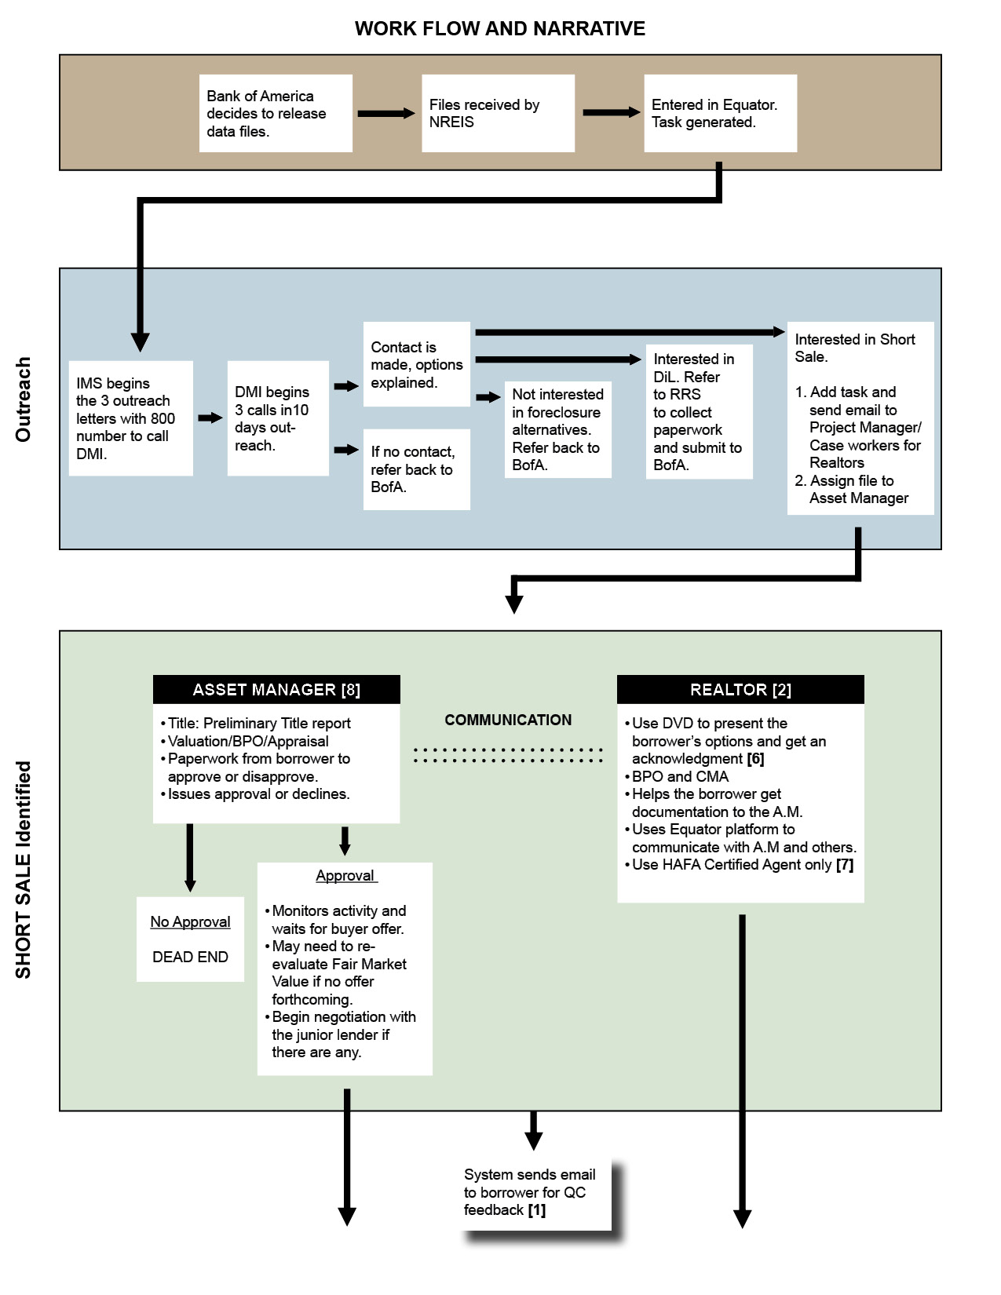

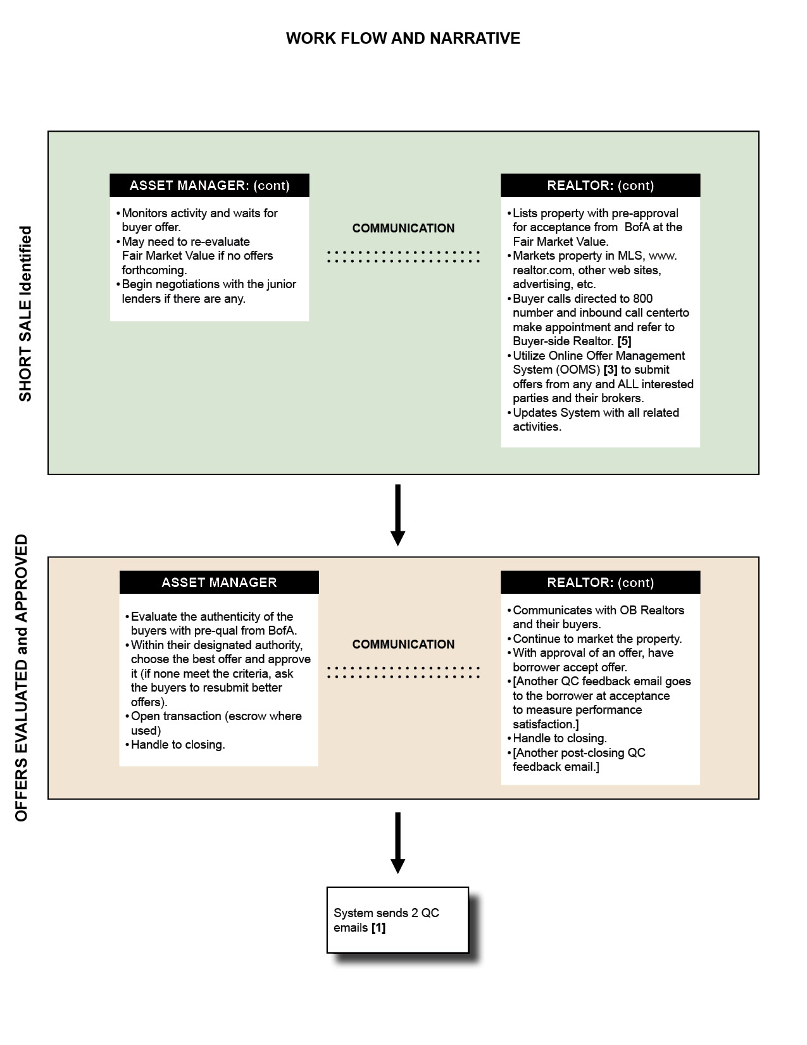

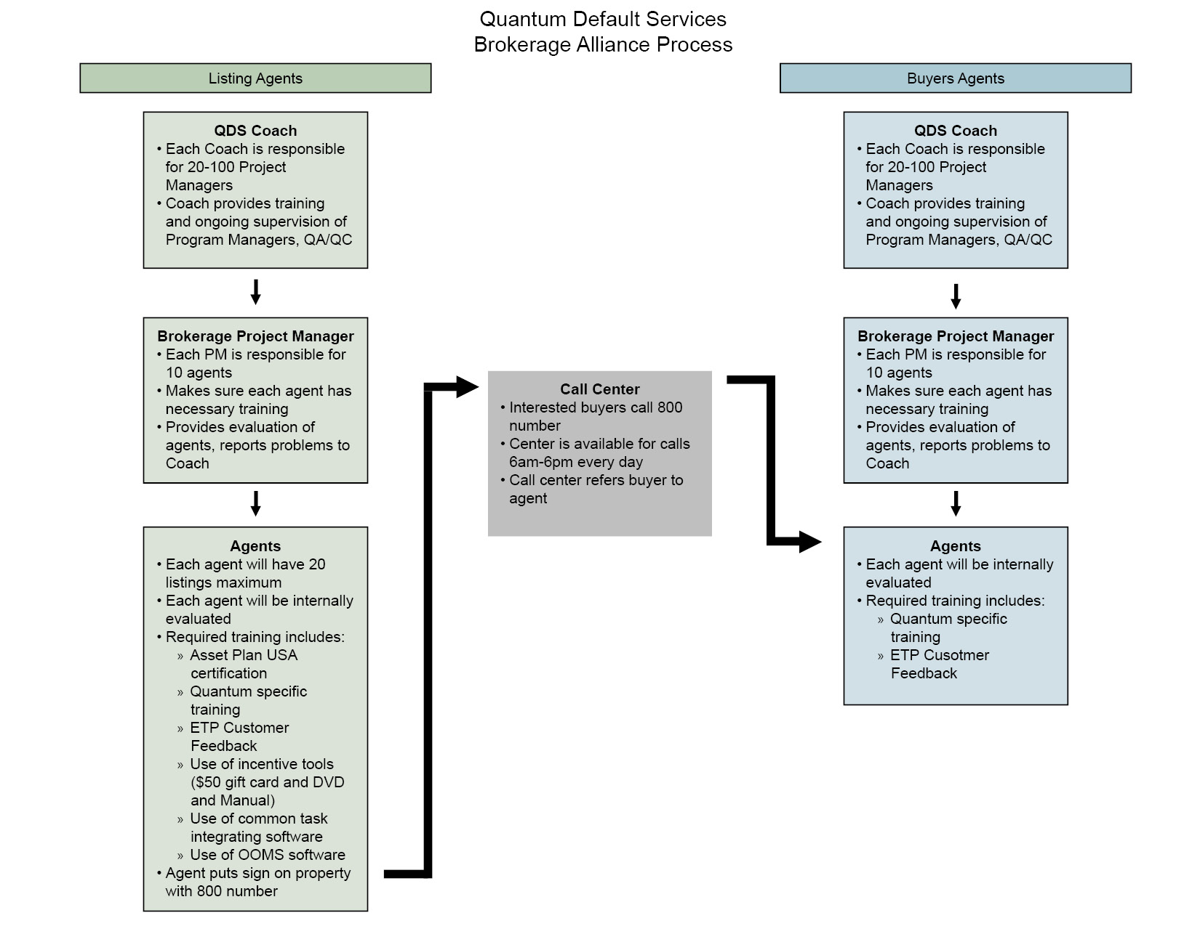

1. Refer to drawing below
2. Refer to drawing below
3. Refer to drawing below
4. Refer to drawing below
5. Refer to drawing below
6. Refer to drawing below
7. Refer to drawing below
8. Refer to drawing below