Tablecloths

Link to Main page for American Hotel Register Co.
http://www.americanhotel.com/

Item # for tablecloths
G2TCR-52X120-D

Link to tablecloths-dark tones

Link to Tablecloth’s

Flipchart

The link for the Flip-Chart....brushed gold aluminum, Number: DR550
http://www.ustechelectronics.com/DraperProducts/DraperEasels/Paper_pad_Easels.htm

Source for Flip Chart Markers
Sanford Number: Item ID: 22478
Sam’s Club Link
or
http://www.samsclub.com/eclub/viewproduct.jsp?item=874004

or
Discount Office Supplies
Discount Office Supplies

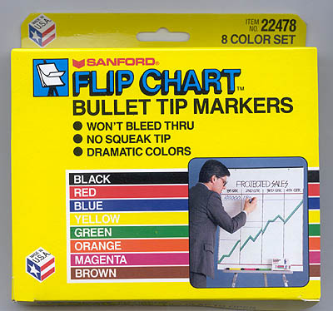

Source for nametag badge insert refills:

Discount Office Supplies
6601 Overlake Place
Newarrk, CA 94560
800-734-6020
Item AVE05392 Avery Name Badge refills 3”x4” 300 a box $15.67/box

Buckhorn-Stowaway Training Bins
513-831-4402 Phone
513-831-5474 Fax
Colors: Grey, Red, Green
1-49 $13.37/ea.
50-249 $12.41/ea.
Min. Order $150 (12 bins)
This is the link for the bins...
Attached Lid Containers
Item Number: AR21150902
http://www.buckhorninc.com/products/attached/attached_3.html

Metal Clip Boards KC 8514
John Soucy Customer Service
1-19 = $4.63
20-59 =$4.39
60-99=$4.15
100+=$3,75
http://www.tannersstorefront.com/saunders.htm

Corrugated Plastic Signs and H-Step stakes

Sign Experts – Paul Stojeba
2044 Rose Lane
Pacific, MO 63069
636-257-3565
636-257-3566 fax
800-874-9942
877-688-1863 fax
www.signexperts.com

Printers for forms

Valmar

1400 Plaza Blvd., Ste. A
National City, CA 91950
619-474-7531 Business
619-474-6757 Fax

Contact: Vince or his assistant Doris

valmar1@pacbell.net

See Next Page Price Sheet
PRICE LIST FOR PRINTING
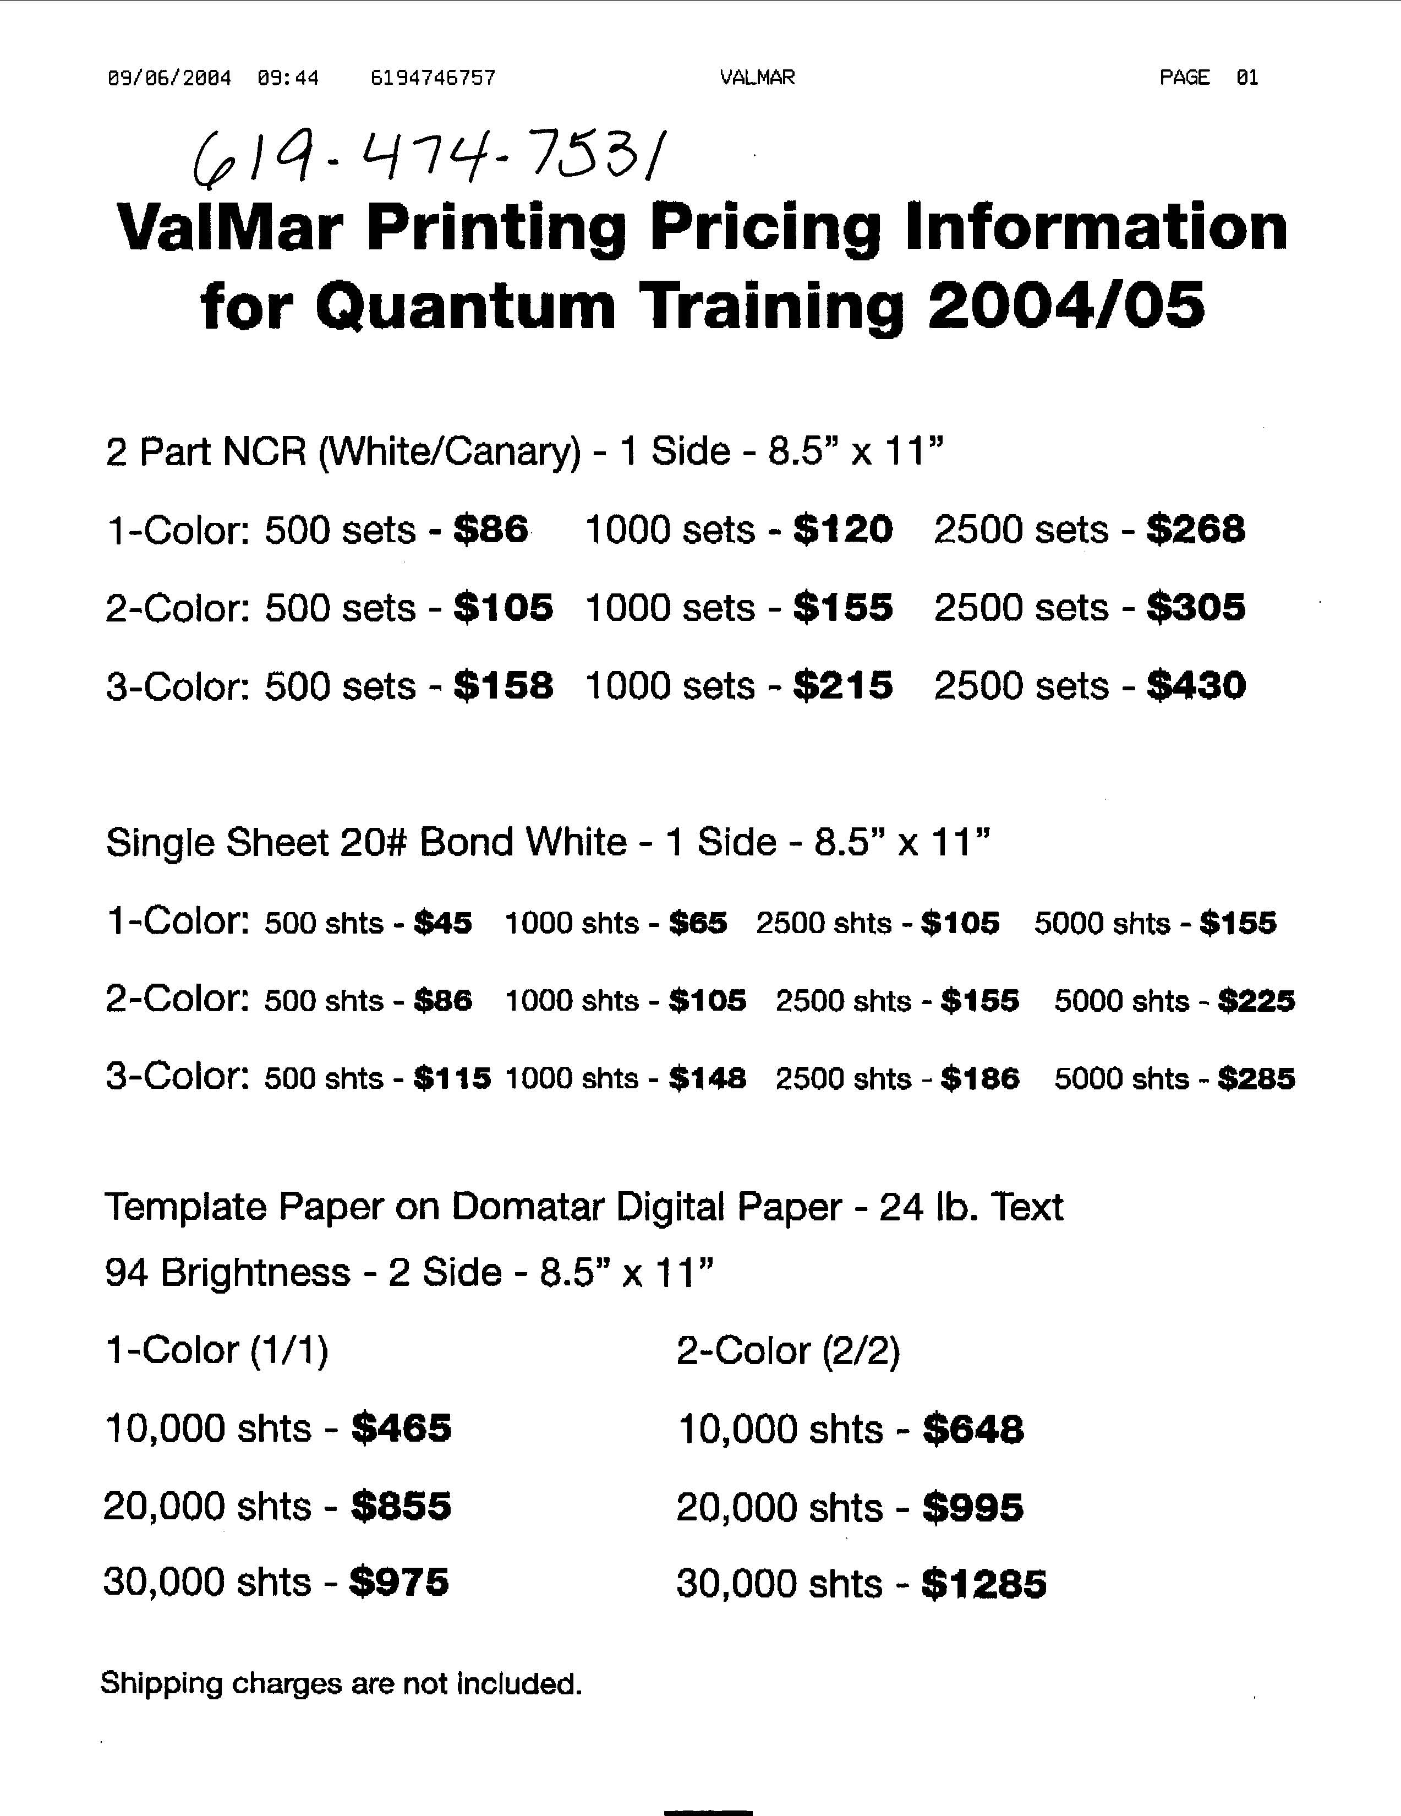

Copy Pak
1597 West 9000 South
West Jordan, UT 84088
801-565-1818

Quinn Stirland, Owner
801-414-6872 Cell
801-255-6262 Fax

Wooden Pointer Sticks- 36”
Buy Pointer from Demco Product Number WS17168460

Be sure to put in Product #WS17168460 in search field

Overhead Projector Cart

American Hotel Register Co.
Item #R4VOHT-42 Mobile Table for Overhead Projectors 32”W x 34”H x 24”D

AV Cart for TV and VCR/DVD player
Click Here for AV Cart

American Hotel Register Co.
Item #R4VLE-54 Video Table 54” high 32”W x 24” D
Enter Item number R4VLE-54

NOTE: You can order a catalog directly from Hotel Register Co. by calling: 800-323-5686 or on line @ Hotel Register Company

The catalog show pictures of all items-

Atomic Clock (small travel clock)

http://www.ambientweather.com/tralclwihiba.html

Walgreen’s and Costco also sell them

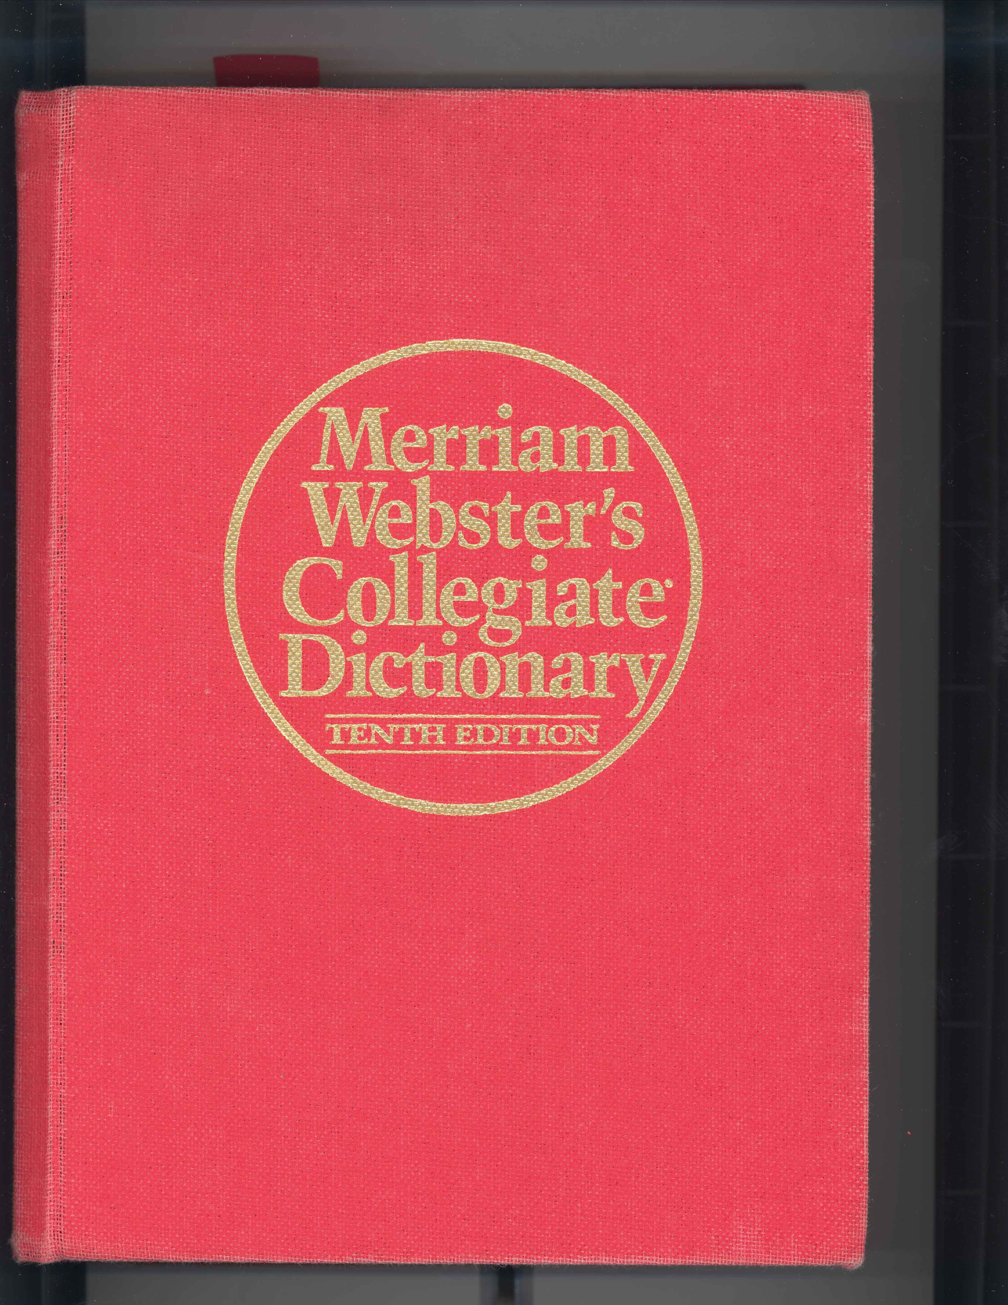
Merriam Webster’s Collegiate Dictionary-Eleventh Edition ONLY

Quantum Home Tour Slanted Plastic Stand
8 1/2” x 11” Slanted
OfficeMax
No. 2033-5004//9649OIOM

Click on this link to shop @
Shop Online at OfficeMax
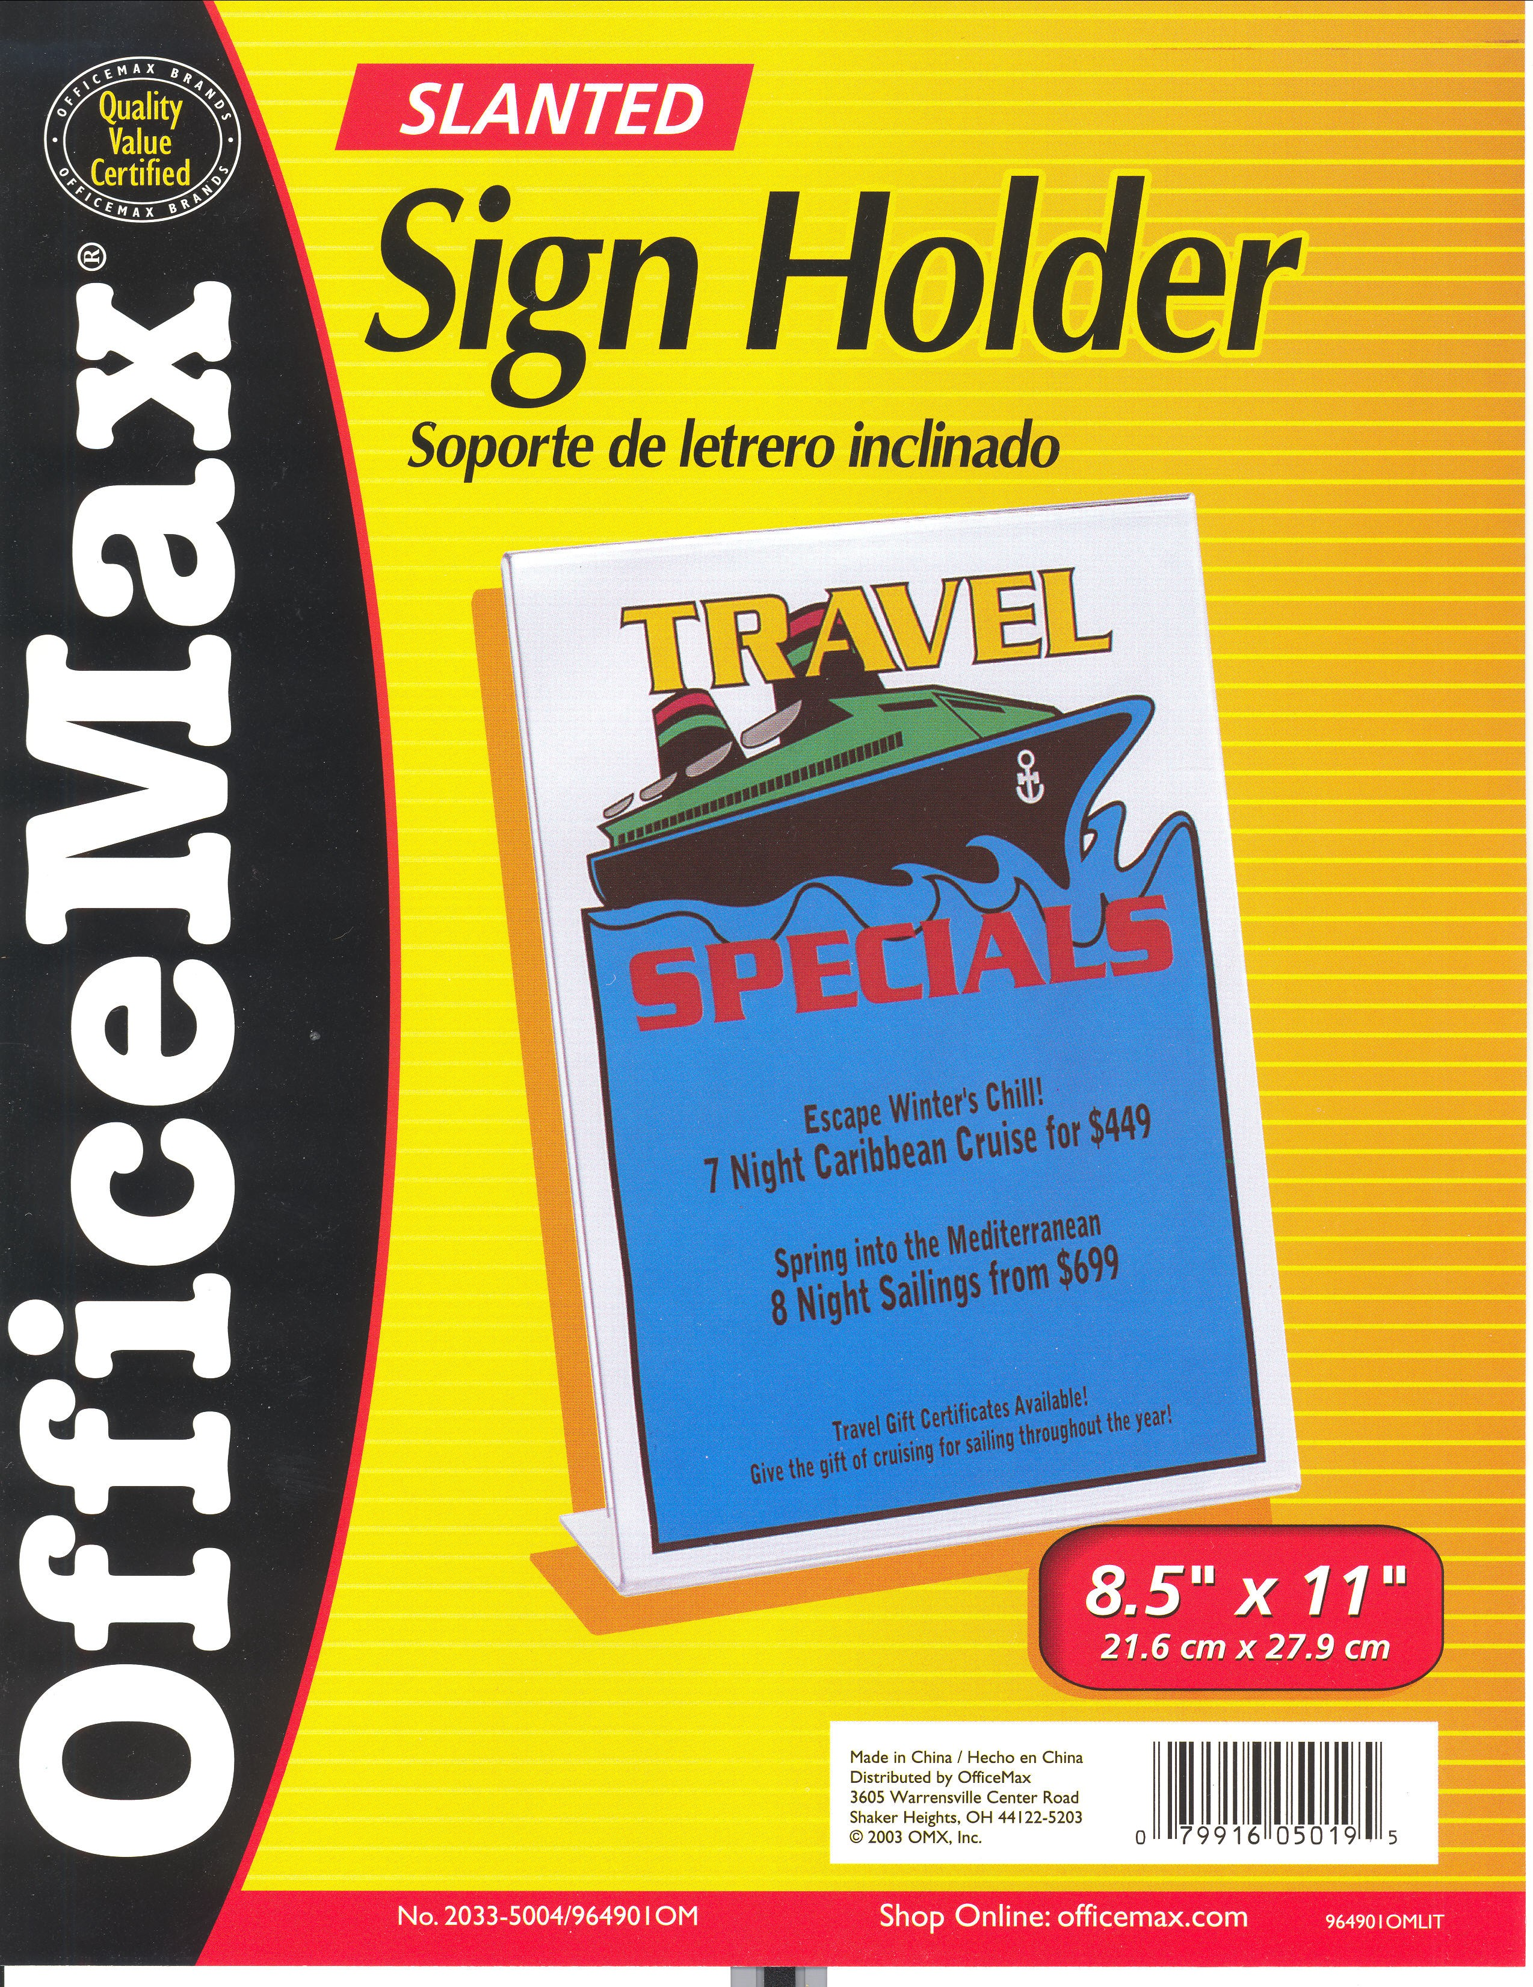

Metal briefcase for traveling-carry training materials
Special Offer
Anvil Attache Case
Special Price: $89.00
To order call 1-800-359-2684 (FLY-ANVIL).

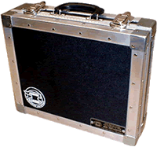

http://www.anvilcase.com/

Click on specials

Click Here: Books can be purchased at Amazon.com


Dr. Seuss Book

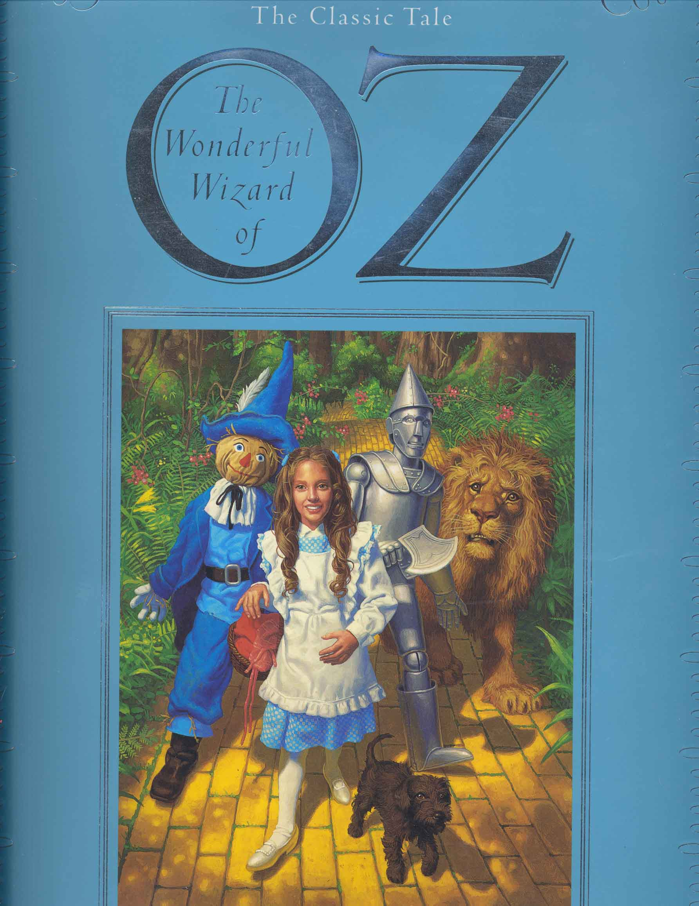
The Wizard of OZ

Wood Clip Boards – Let them know Quantum Management Referred
SPIRITWOODGIFTS.COM
Be sure to order Legal Size; You must call, delivery approximately 1 week.
You must call and specify legal size. They are $5.00 more than the price on web for letter. Order by PHONE? no problem just dial 206-898-6955
Click on link to see options and styles
Spritwood Executive Clipboards
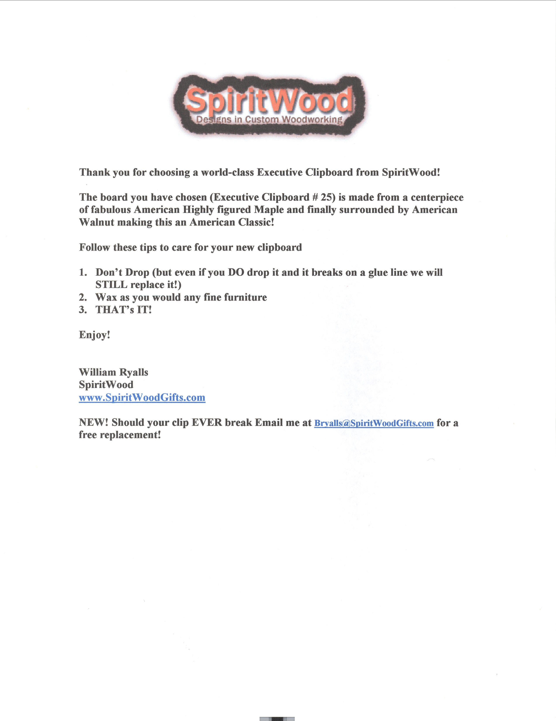

Click here to order Laser Pointer/Pens

http://www.wholesaleforeveryone.com/page/WFE/CTGY/laserpens

http://store.greenpearle.com/laserpointers.html

