October 10, 2000

«First» «Last»
«Address1» «Address2»
«City», «State» «Zip»

Dear «First»,

Congratulations on passing your real estate exam! This accomplishment is your first step toward an exciting and rewarding career in real estate, the type of career you can have with the proper training and support, the type of career The Journey to Mastery can help you achieve.

Prudential Preferred Properties’ Journey to Mastery program uses an unique system that provides the opportunity to work hand-in-hand with seasoned sales agents while participants also engage in intensive seminar sessions integrated into their work; sessions that will give you the skills in time-management, prospecting and networking that turn leads into appointments and appointments into contracts.

The Journey to Mastery program is a world-class program, created by a national consultant and trainer. It has been designed to help newly licensed agents become productive in as short a time as possible. It helps you develop the contacts and confidence a successful real estate agent needs while learning how to use these tools to your best advantage.

We offer this nationally recognized training program at no cost for qualified individuals who work and stay with Prudential Preferred Properties. So, if you are serious about your new career call today and schedule an appointment to learn more about Prudential Preferred Properties’ Journey to Mastery program.

I look forward to your call.

Sincerely,

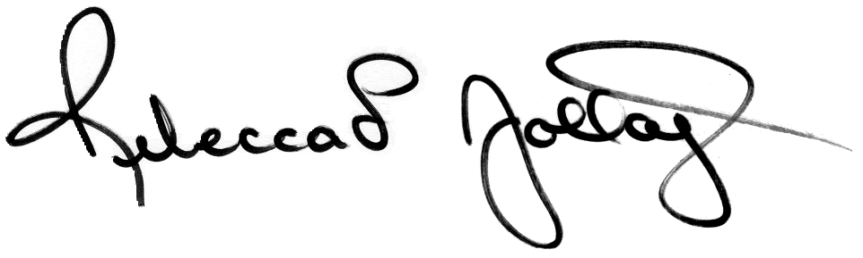

Rebecca L. Jollay
Director of New Agent Recruiting
Prudential Preferred Properties
312-264-1280 Direct Line
312-933-7885 Cellular
rjollay@prupref.com

“When I got my license I was nervous about getting started. I knew that getting the proper training was going to be crucial for my success. Prudential Preferred Properties’ Journey to Mastery program was exactly what I was looking for. The support and hands-on training that I am receiving helped me write my first contract within 30 days in the business. This program is powerful, insightful, and I would not trade its’ dynamics for anything in the world.”

Mary Fran McMahon
Prudential Preferred Properties

New Agent, 1999

"The Journey To Mastery Program has given me a level of support that I feel is unbeatable. This is a program that clearly demonstrates Prudential's commitment to each individual agent's success. I found the training to be meaningful, informative, as well as inspirational. By the time you finish the program you will possess techniques, skills, work habits and a confidence level it takes other agents years to develop."

Anne Discepolo
Prudential Preferred Properties
New Agent, 1999

