November 7, 2000

«First» «Last»
«Address1» «Address2»
«City», «State» «Zip»

Dear «First»,

Congratulations on passing your State of Illinois real estate license exam! This accomplishment is your first step toward an exciting and rewarding career in real estate. The type of career you can have with the proper training and support, the type of career The Journey to Mastery can help you achieve.

Prudential Preferred Properties’ Journey to Mastery program uses an unique system that provides the opportunity to work hand-in-hand with seasoned sales agents. Participants engage in intensive seminar sessions integrated into their work; sessions that will give you skills in time-management, prospecting and networking that turn leads into appointments and appointments into contracts.

Journey to Mastery is a world-class program, created by a national consultant and trainer. It has been designed to help new licensees become productive in as short a time as possible. It helps you develop the contacts and confidence a successful real estate agent needs while learning how to use these tools to your best advantage.

We offer this nationally recognized training program at no cost for qualified individuals who work with and stay with Prudential Preferred Properties. If you are serious about your new career, call today and schedule an appointment to learn more about Prudential Preferred Properties’ Journey to Mastery program.

I look forward to your call.

Sincerely,

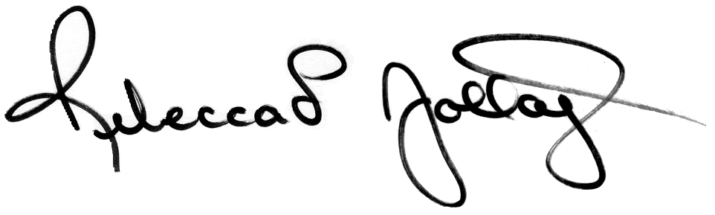

Rebecca L. Jollay
Director of New Agent Recruiting
Prudential Preferred Properties
312-264-1280 Direct Line
312-933-7885 Cellular
rjollay@prupref.com

“When I got my license I was nervous about getting started. I knew that getting the proper training was going to be crucial for my success. Prudential Preferred Properties’ Journey to Mastery program was exactly what I was looking for. The support and hands-on training that I am receiving helped me write my first contract within 30 days in the business. This program is powerful, insightful, and I would not trade its’ dynamics for anything in the world.”

Mary Fran McMahon
Prudential Preferred Properties – Chicago Office

New Agent, 1999

“Thanks to Prudential Preferred Properties’ GREAT training program and their support for brand new agents, I was able to present myself with confidence to the public as a realtor from my first week in the business. Five months and four sales later, I am well on my way to building a successful business. And now, I have confidence from my OWN experiences.”

Lynn Chamberlin
Prudential Preferred Properties – Evanston Office
New Agent, 1999

“I’m glad I joined the Prudential Preferred Properties firm. I especially appreciate the frequent training opportunities, which are always helpful and supportive. I am very grateful that agents relate to each other in a more cooperative than competitive way. And, of course, the office is beautiful and comfortable – a pleasant place in which to work.”

Doris Rudy (a recent graduate from Journey to Mastery)
Prudential Preferred Properties – Evanston Office
New Agent, 1999

