
Hi Everyone:

This is a request for your help and support!

We are trying to promote agent participation in Prudential Preferred Properties exciting new program created and developed by our President and CEO, Doug Yeaman. The Journey to Mastery program provides new agents with the training and skills set development necessary for their future in the real estate industry.



“I had been with Coldwell Banker for 9 months before coming to Prudential Preferred Properties. I was definitely on my way out of the business. I learned more in 2 days with the Journey To Mastery than I had learned the entire 9 months I had been in the business.”

Lisa Kent, Winnetka Office

The Journey to Mastery program is specifically designed to help newly licensed agents become productive as early as possible. Our goal is to teach new licensees time-management skills, how to prospect and network, how to effectively turn leads into appointments, and how to turn appointments into contracts.

Teri Tuffner, our Director of Career Development, is the training manager for the Journey to Mastery program. She is solely responsible for getting our new licensees up and running, and driving their production. Teri runs both a city and North Shore training program to fully cover all of our areas of expertise.

I help people in many different aspects of their new real estate careers, from pre-licensing classes, to bringing direction to a not-so-directed sales career. My primary focus is helping people decide if full time real estate is right for them. I then take them through all of the necessary steps to obtaining their real estate license.

I would love to work with anyone you know who is thinking of getting into real estate, or who has recently obtained their license. Our training program will provide them with the tools necessary to become productive quickly, and will put them on the road to a successful career in real estate.
I am asking for the names of anyone you know who should be considered for a sponsored career with Prudential Preferred Properties.

I can be reached at:
rjollay@prupref.com or 312-264-1280.
I look forward to hearing from you soon.

Sincerely,
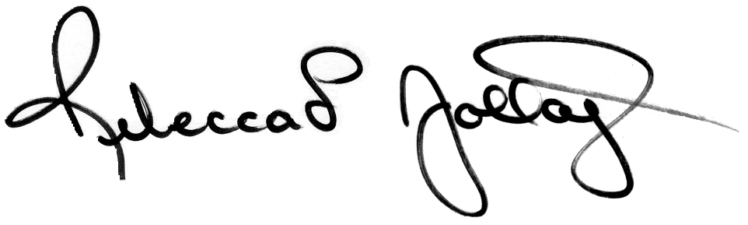
Rebecca L. Jollay
Director of New Agent Recruiting

