QuREOs - Innovation in REO Practices

A “Green” Light in the Darkness
As the United States has seen its housing industry crumble and markets hitting lows not seen in many decades, many forecasters suggest hard times lie ahead along with long, uncertain paths to recovery. Yet, with a little innovation, the path out of the 2009 foreclosure crisis may be simpler than many economists think.
The 2009 foreclosure crisis has illuminated many weak points in the U.S. financial system with regard to the housing market. One such weak point is the current process commonly used by note holders in REO sales. This process was designed for the quick-turnaround, “as-is” sale and, therefore, only loss mitigation, of only a few properties per year at each financial institution, rather than the tens, if not hundreds, of thousands of foreclosures commonly seen today.
We have created a multi-party process that is mutually beneficial to all of the involved parties, including: banks, other financial institutions, real estate firms and agents, and cities and other community entities, such as homeowner’s associations. The first step to changing and updating the REO process is realizing the potential that green building concepts have for erasing the stigma on the millions of properties now considered to be “toxic assets.” These properties got that undesirable nickname due to the foreclosure label and having been sitting vacant, and possibly having been stripped of significant value and/or having fallen into disrepair. With some basic renovations, these properties may qualify for Certified Green labels, which make the properties much more attractive to buyers, who may then be willing to pay a fair market price, rather than seeking a bargain. This, in turn, allows the note holder to maximize the return on the asset, rather than taking a loss due to a quick, “as-is” REO sale.
In addition, the recent history of marketing these properties has been done by individual agents or “teams” who have become property managers not marketers. In the rush to get them sold these agents have simply put them on the local multiple listing services and waited for offers. Properly renovated and managed for marketing, these properties could be offered to many real buyers versus the one who comes with the first right offer. In our focus groups on these issues, we found that it was not unusual for an REO agent to have two cell phones; one that they answered and one they did not. The one they answered was from the banks and the one they did not was from buyer inquiries. Clearly, effective marketing and lead capture together with the proper renovation optimizes the return on the asset and shortens the time.
However, incorporating green property rehabilitations/renovations into the REO system will require some changes to the overall system. Implementing these are the next steps in our plan. We foresee the following needs: Note holders will demand much stronger accountability; real estate firms will look for and receive greater control of the renovation and marketing of properties they list; and all involved will require stronger, streamlined communication and interaction.
Looking at this list of needs, it is important to understand why new solutions are necessary, and how the current system no longer fits the needs of all parties involved.

A Shared Pain
The rash of foreclosures plaguing banks in 2009 is not the problem of the U.S. financial system alone. Instead, it is a source of pain that is shared by many entities, including the following:
- Note holders
- Realtor Listing Agents
- Realtor Buyer Agents
- Real Estate Companies
- Buying Consumer
- Communities
Each of these interested parties is hurting because of the economic situation that has become all too normal in 2009.

Note Holders
For the note holders, whether banks or investment companies or others, the foreclosure crisis has found them accidently thrust into the property management and real estate business.
Previously, this would not have been as much of an issue, because the volume of REO properties was relatively small; there was a functional system in place to handle the process of recouping an investment, or at least minimizing the loss, from these problem properties. One part of this process involved using an REO agent and Asset Manager to take over the auction/sale of the property. It has been common for Asset Managers to receive portfolios of 100,000 properties to distribute to listing agents. But with the skyrocketing number of properties involved, Asset Managers are overloaded, and those already large portfolios have become unwieldy. At the same time, the Legal and processing systems are overloaded, too. In the past the individual agent could handle 15 to 30 properties; no single agent ever, could effectively manage and market 50 –100, which is not uncommon now. What is being compromised as the result? The answer is marketing, lead capture and renovation management thereby maximizing the return on the asset.
The system of how banks or other financial institutions usually handle foreclosed properties was not designed for large quantities of properties. In fact, until the subprime housing bubble burst, each institution having only a couple or a handful of foreclosures was the norm. Because the note holders were less concerned with getting top dollar than with loss mitigation, it was not terribly necessary for the Asset Manager to carefully sort through the properties and evaluate them before assigning them to listing agents, or to diligently communicate and keep track of potential buyer leads. Still, before 2009, using an Asset Manager made sense, as note holders did not need or want to be in the property business.
Adding to the burden, the properties piling up on note holders come with their own baggage, including a definite stigma of being a “foreclosure”. Any fines levied on the property by communities or homeowner’s associations during vacancy, and the possibility of not having basic amenities, such as appliances and fixtures, that may have been removed by previous homeowners and sold for cash has in some instances, escalated to a crisis level.
All of this makes it less likely the note holder, using the current REO system, will be able to maximize the return on the properties, or even to quickly sell the many REO properties without substantial losses.

Listing Agent Realtors – not companies but individual agents and/or teams
Listing Agent Realtors, whose job it is to list and manage the property through the sale, have seen the rising flood of foreclosed properties hurt their profitability.
The listing agent is responsible for listing the property, marketing it and cleaning it. Because foreclosed houses are most often sold “as-is” and the listing agents have limited personal capital to invest in getting the properties in reasonable shape for sale, any properties in poor shape or requiring additional expenses dip into the agent’s profit margin. While the note holder repays the agent for the rehabilitation costs, It is not uncommon for a Listing Agent to have several hundred thousand dollars in receivables pending.
Beyond this, it is not unusual for a new REO property to generate an extremely high volume of interested buyer calls or leads. Listing agents often are unable to monitor phone systems and return a large volume of calls from buying agents or consumers in a timely manner. Because of this, opportunities easily can be missed, causing further losses of potential income. The numbers of calls can be so great that a Listing agent simply does not have the time or resources to answer all of them.

Realtor Buyers Agents
One of the biggest concerns in selling a property quickly lies with the agent(s) responsible for handling interested potential buyers. For the Realtor Agents the volume of calls and the number of properties can be overwhelming. The lack of timely communication about the properties and getting information to a potential buyer costs the note holder real money. It is not unusual for the listing Agent Realtor to not return phone calls quickly and in many documented instances not at all. Offers are often only accepted as “faxed in” and sometimes not even presented. The Asset Manager does not communicate directly with buying agents and often doesn’t even know of potential better “other offers”. Leads are also generally lost in this process, as they may not be reported, monitored or marketed as needed.

Real Estate Companies
Real estate companies take on the legal responsibility for all of their listings. However, in the case of the REO properties, the companies do not have control over distributing these listings.
The companies also see potential income lost when buyers’ calls are not returned. The companies depend on sales leads for their business, but there is no way to track how leads garnered from the REO listings are being handled because the listings frequently go directly to the agent or agent-team instead of being distributed through the company. Another fault with this system is that once the REO property has been sold, the Real estate companies are often stuck with the after-sale liability with the buyers.

Buying Consumers
The system does not work easily for Buying Consumers either. Often, the consumers looking at foreclosed properties are in the market looking for a bargain. However, there are several things that may preclude them from buying a foreclosed house.
First, they may not know what properties are available and gaining information about this may not be easy. Second, they may not have the financial resources to take on the repairs needed for a property sold “as-is.” Third, the available financing options may not be what they want. Fourth, they may be reluctant to buy in an area with many foreclosures now seen as blighted due to vacancies and disrepair. Fifth, getting information and making a decision can be difficult or simply not available.

Communities
Communities hit with multiple foreclosures find themselves with houses that fall into disrepair, blighting the neighborhoods and driving down property values, and therefore the community’s tax base. As repairs are left undone, or basic maintenance falls by the wayside, health and safety concerns rise. It is not uncommon for windows to be broken, letting in the elements, or animals or vagrants to enter the structure, leaving behind waste or garbage.
In addition, houses that lie within neighborhoods tied to a homeowner’s association may see fines and fees levied against the property. In some cases, cities have placed fines for neglected maintenance or for city services, such as trash and sewer service. However, if the property is not sold, the communities will not see the money from these fines and may instead see the condition of the property continue to plummet, further hurting the community.

A Complex Problem
The pain that the aforementioned parties share from the 2009 foreclosure crisis is not easy or simple to cure. Yet, the best solution involves a lot of simplification and even more innovation.
The overall process needs to be changed to eliminate the one to one relationship between an Asset Manager and a small umber of Realtors. It is better to allow Real Estate Companies to do their jobs without being micromanaged. Communication, including phone calls and human interaction, needs to be fast and simple between all interested parties. Accountability must be built into the system. The new system needs to work for a large volume of properties from one holder, rather than only a few. It also must take into account the rehabilitation of the property that removes the stigma of the “foreclosure” or “toxic assets” labels, and incorporates the much more consumer-friendly Certified Green label. Above all, the system must work efficiently and profitably for all involved.
Finding a Solution
The solution is three-pronged. It addresses a lack of communication, gaps in accountability between involved parties, and the stigma surrounding the foreclosed properties in this market.
The following chart illustrates how the new process works:
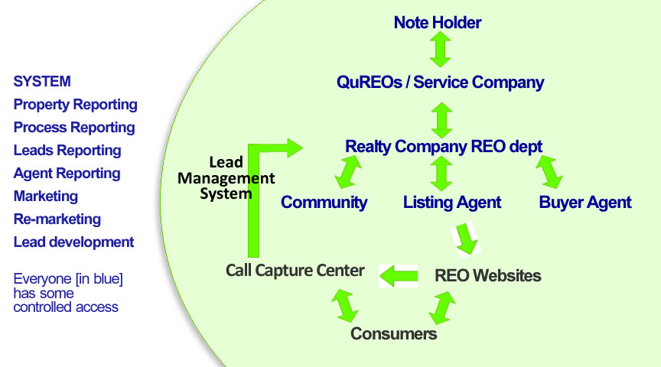

First: Note Holders shift the responsibility for rehabilitating the property to the Real Estate Company’s REO Department, rather than to an Single Realtor Agent, managed by an Asset Manager. From there, the REO Department works with the Community, assigns the Listing Agent and the Buyer Agent. All of these parties have some controlled access to an overall database of accountability reports. Working with, but separate from, these people are three other elements, two of them new to the process:
Second: Our Lead Management Center handles and captures phone call leads. Plus an REO Website that details the available properties allows offers to be initiated via the web and is available to real estate agents and the Consumers themselves. These are all the partners in this new system, each with a stake in making the system work.
The two new elements fill in the communication and accountability gaps in the current system and foster interaction between all parties. The REO Website allows buying consumers to browse listings and quickly find out information about these properties. By implementing a Lead Management Center there is a guarantee of someone to field calls and direct them to the appropriate recipient which lessens the chance for miscommunication or dropped leads.
For accountability, reporting is standardized for all aspects of the property, including: renovation management, offer processing, capturing buyer leads, the activities of the listing and buying agents, marketing strategies, and lead development activities.
As for the properties themselves, a big change that facilitates a profitable sale is mitigating the foreclosure label from the property by rehabilitating/renovating it prior to listing and obtaining a Certified Green label. Instead. The Real Estate Company REO Department oversees the renovations, which are done by local contractors and companies that follow established processes and are held to the highest standards of accountability. Once completed, these renovations allow for maximum return on both the original investment and a slight re-investment in the property.

Capturing Buyer Leads
The Lead Management Center handles initial buyer calls/leads. Information about the call is immediately entered into a database and then the call is referred to the appropriate party: a mortgage broker/lender when appropriate and a buyer-side agent.
At this point, the lead is captured and managed. The captured lead is personally contacted by the buyer-side agent who makes an appointment to determine his needs and gets permission to continue to contact him with future information. The buyer-side agent then has the opportunity to re-market appropriate new listings and eventually sell something. The mortgage broker or lender has an opportunity for business as well. These parties also report their activities garnered from the contact, adding a layer of accountability.
Lead Management System

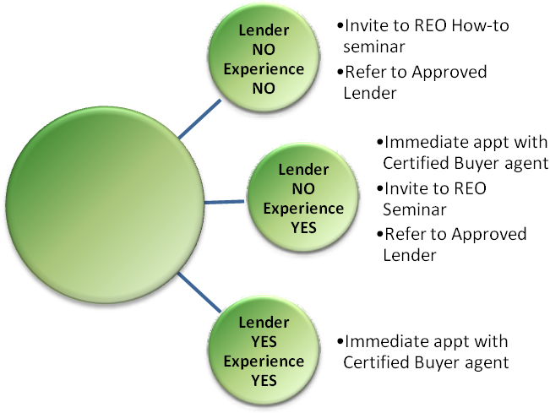
Incoming
Caller
Initial talk with
Lead
Management
Team

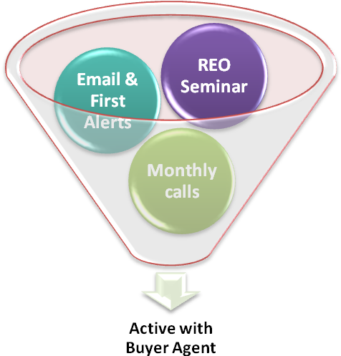

Marketing Properties
The new system’s marketing process is streamlined for efficiency. First, a dedicated sign phone number goes to the Lead Management Center. Next, the properties get green renovations by the Real Estate Company REO Maintenance Department. Then, the property is assigned to a Listing Agent, at which point it is entered into MLS and made available to browsing consumers on the QuREOs REO Website, all offers are delivered to the listing agent monitoring and managing against a timeline. Also, an REO Home Tour™ (RHT) is scheduled and reported to the database. The RHT™ drives sales by bringing in interested consumers to the newly rehabilitated/renovated Certified Green property using unique - proprietary marketing technologies.

Real Estate Agent Accountability
Micromanaging real estate agents together with real estate companies ensures the level of accountability necessary for a transformation in marketing REOs to be effective. Currently the level of accountability for agent performance is marginal if it exists at all. Agents are assigned only after being certified and all activities are reported and monitored. Also, all leads are monitored and automatically managed through Customer Relations Management Software, CRM. The assumption that agents will capture and manage leads is woefully in error. The industry standard for lead capture is less than 4% with good systems but marginal accountability. Agents and companies will report results from marketing events, such as RHT and inbound sign calls and QuREOs will provide regular support, monitoring and follow up. All results in the chain are monitored and managed.

Asset Management Accountability
All of the work undertaken to manage the property by the Real Estate Company REO Department is streamlined and automated, with reports from other parties, as well as activities and results, being recorded directly to the database. Management involves monitoring these activities and results, without micromanaging the interested parties. A Professional Services team previews all portfolios before assignment, 1) to determine quality of each property, 2) it’s potential to obtain a loan, 3) become an investor sale, 4) go to auction or 5) become part of a bulk offering.

Real Estate Firms Accountability
Real Estate Firms are responsible for reporting on and monitoring management of the property and its rehabilitation/renovation. The firms control the rehabilitation work, as well as determine which agents are assigned to which properties. The firms have greater tools in determining agent effectiveness due to the comparison reports generated from the new system’s great accountability and data collection. The companies are greatly invested in the effectiveness of their agents because the more effective the agent, on lower commission splits, greatly affects their bottom line.

Green is the Future
As the U.S. moves toward greater implementation of carbon cap-and-trade programs, houses with Certified Green labels will become more and more important to communities seeking to capitalize on their carbon footprint. Green technology also makes houses more attractive to consumers, as one of the essential principles of green building is energy efficiency, which lowers the cost of ownership for consumers.
The Note Holder decides what level of re-investment to put into a property to maximize the return at sale. There are several different options for the type of rehabilitation/renovation. Different levels of green certification can be chosen, and all work can be put out for bids from local companies. Once the work is completed, a certified inspector visits the property and the appropriate label (“Certified Green Level 1”) can then be used in marketing the property. This adds instant value to the property, at no additional cost to the note holder and the foreclosure stigma has been lifted.
It is understood that this program applies in markets where it is feasible and needed. This will be implemented on a market-by-market basis. QuREOs is in the final stages of negotiating and has a tentative commitment from a major national home materials supplier to partner with the renovation process. This will reduce costs, standardize materials and insure that the “green” materials are in stock and meet specifications.

QuREOs Provides:
Licensed real estate brokerages which meet the following performance requirements:
- Leaders in their market
- Strong, proven RELO or REO departments
- Local, regional firms with sufficient geographical coverage and a large enough agent population competent and capable of meeting our stringent performance standards.
- Strong local reputation and connection with cities
- Financial capacity to manage the float on re-habilitation costs
Agent Training and Certification
With 30 years of training and productivity experience, we provide specific training for Listing agents, which makes them more effective and efficient in their practice with REO properties.
We provide specific training and certification for Marketing/Buyer agents specific to marketing properties, communication and lead management.
Open House-marketing technology (REO Home Tour™) which has been proven to drive buyers to the property and capture leads at 60%. [Most open houses capture leads at less than 2%.]
Property/File Tracking Software Application
A highly developed reporting system, which makes all appropriate aspects of the property file available to every person in the matrix in real time.
It is available before the REO process starts to ensure communication between the varying departments of the note holder.
We provide summary and detailed reports for evaluation and decision making.
Lead Management Center
We know from research over the past 30 years, Realtors do not effectively handle incoming calls from buyers. We have created and manage a professional inbound call center to field all the calls from the websites, advertising and sign calls. We are the leader, nationally in addressing and fixing this issue.
The Lead Management Center collects initial information including name, phone numbers, email address and areas of interest. They make an initial determination of the depth of interest of the caller, as well the best time and way to contact them.
The Lead Management Center forwards that information to Customer Relationship Management system that the Buyer agents and the REO department uses to manage leads.
We monitor call wait time to be sure calls are not waiting and lose the call.

Customer Relationship Management (CRM)
A sophisticated computer system which supports the repeated marketing of property to buyers and provides accountability for the quality of work by Buyer-side agents.
- Hunts for an appropriate agent who can respond to the caller as quickly as possible.
- The assigned Buyer-side agent returns the call, makes an appointment and collects detailed information about the caller and enters the information into the CRM database.
- The prospect information is updated at every contact by the Buyer-side agent.
- The CRM system is used to subsequently market new properties and keep in contact with potential buyers.
- The Lead Management Center and CRM system serves to hurry the selling process by having buyers stay in the loop and having them pre-approved for making an acceptable offer.
- The CRM allows the REO department to monitor and evaluate the work of certified Buyer-side agents.
- The CRM re-markets new listings to the interested buyers automatically
Accountability
- Provide oversight for standards of performance by all the people and systems involved
- Make certain all agents meet performance standards
- Monitor brokerage performance
- Assure that Lead Management Center performs properly
- Interface with software applications
- Summary and detailed reporting for all involved
Green Solutions technology
- Uses bulk buying and local vendors to keep costs within normal guidelines
- Uses local business and suppliers to support local economy
- Tax rebate incentives for note holder
- Neighborhood quality and Tax incentives for communities
- Long term cost savings for buyer
- Better loan choices for buyer
City and HOA interface
Through the leadership of the real estate consortium, a powerful partnership can be established with the local communities and HOA to provide them with tools and technology to mitigate the damage done by rising rates of foreclosures within their communities.
QuREOs - Who We Are

QuREOs is a company formed by the combined resources of Quantum Management Systems, Inc. and David Boxall
Quantum Management Systems
- Over thirty years in the business of Management Consulting
- Real estate training systems used by many of the top national real estate companies
- Management consulting to the real estate industry
- Real estate agent productivity programs
- Scientific Marketing systems for real estate lead management
- Specific marketing technologies that drives sales at a higher price and in a shorter period of time and produces buyers
David Boxall - Greenovation Institute and Greenovation LLC
- Head of Asset Management Marketing and Vendor relationships for Wells Fargo
- Head of Premiere Asset Services Division
- Systems Analysis.
- While at Wells Fargo, he experienced the faults in the current REO system firsthand, and is now working with Quantum to streamline the system, as well as diving into the green building technologies that will pave the path out of the current foreclosure crisis.
PMH Financial
- A full service provider of real estate, asset management, and default services.
- PMH Financial is a financial services company offering a variety of products and services related to residential mortgage servicing, collections, legal services and asset management
- PMH Financial is an independent business unit of Braddock Financial Corporation.
- Braddock Financial Corporation is an SEC-registered investment adviser that specializes in the structured finance sector of the fixed income market and invests primarily in MBS (Mortgage Backed Securities) and ABS (Asset Backed Securities). The company was established in 1994 and currently manages more than two billion dollars in assets.
Installation Team
- Douglas M. Yeaman – President and CEO of Quantum Management Systems, Inc. and officer of QuREOs
Doug Yeaman, has trained more than 140,000 professionals, is the founder of Quantum Management Systems. A highly respected management consultant, he is known for his ability to create people-effective systems and train and consult within organizations, enabling them to become high-performance work groups, significantly increasing profitability. He has worked for 30 years extensively within the real estate industry and his work includes most of the best-run real estate companies in the U.S.
Mr. Yeaman's track record includes founding a soft drink company at the age of 23 which he subsequently sold to a Fortune 500 company and began to establish his now national recognition and reputation. Mr. Yeaman spent several years as a business consultant in Europe and the United Kingdom. Upon his return to the United States in the early 1970's, he organized a large management consulting company in the San Francisco Bay area. The firm specialized in organizational development, management consulting and training. His education is in physics and math with extensive post work in management and human resource development.
- Sherry Pitcock – Senior Consultant and Partner with Quantum Management Systems and office of QuREOs
Sherry Pitcock is Director of Business Development with Quantum Management Systems and an officer of QuREOs. She has been a Realtor for thirty years, a manager since 1988. She has managed top real estate offices for Prudential California Realty, Coldwell Banker, Jon Douglas and held training positions with other companies like Fred Sands and Keller Williams. She fully understands real estate at all levels, including the issues of managing agents and creating accountability around their work. She is uniquely prepared to understand the issues involved in system design, training and working with agents and managers to implement a successful program.
Prior to her real estate career, she was a rocket scientist and mathematician that brings a valuable analytic approach to the work.
- Ellaine Calhoun – Formerly, Senior Loan Office with Prudential Mortgage Bank – Officer of QuREOs
Ellaine Calhoun is Operations officer for Quantum Management Systems and an officer of QuREOs. She was in banking and mortgage lending from 1973 to 1991. She was a senior loan officer for Prudential Mortgage Bank until she left in 1991 to join Quantum. In 1998 she took a sabbatical from Quantum at the request of Prudential Real Estate Services to help start Prudential Preferred Properties real estate in Chicago as it V.P. of operations.
Currently, she is a seasoned trainer and responsible for certifying Quantum’s trainers. She is a highly respected real estate trainer with strong systems management skills.
- David Boxall – CEO Greenovation Institute and Greenovation LLC – Officer of QuREOs
David Boxall – Recently - Wells Fargo Premier Asset Services Vendor and Marketing Director, has now moved into establishing a new enterprise focusing on changing the paradigm for foreclosed REO properties. David is a recognized speaker for several Fortune 500 companies including Kodak, Lockheed, AGFA as well as targeted organizations such as the NRBA and REOMAC. David has also managed several large public companies in his home country, (UK) before making the move to live in the US some twenty-five years ago.

For the past five years David has driven several major marketing and sales programs focused on improving the communication, sales tools and training programs for agents, brokers, clients and vendors within the Wells Fargo family REO marketplace. David’s business experience spans 30 years of senior management, as well as, running his own successful international consulting business. David specializes in identifying leading edge technologies and predicting future market trends while adapting product strategies to take advantage of global opportunities.
One of David’s most publicized achievements was the inception, launch and distribution of Calcomp/Lockheed’s “EcoGraphics System”, a revolutionary dry film imaging system. This was his first move towards developing and marketing products that were considered “Green”. This unique imaging solution was further enhanced and modified under David’s direction by OYO Instruments for the Screen Printing and Flexography markets. This system continues to be successfully deployed around the world today.
- Ken Blevins - President and CEO - PMH Financial
Currently: President and CEO at PMH Financial
Past: President and CEO at Matrix Asset Management
Education: Temple University, Marketing, Real Estate, Finance, and 1987 — 1991
- Robert A. LeFever – Formerly, President of the Southern California Division of Coldwell Banker
Bob LeFever transferred the discipline and skills, which made him a member of the FBI into a successful real estate career. After achieving top producer status early on in his real estate career he then started his own full service brokerage firm in Florida. Merrill Lynch acquired Bob’s company and he experienced rapid professional growth within that organization culminating in his being named President of Merrill’s Southern California operation.
From there he was selected as President of the Southern California Division of Coldwell Banker where he spearheaded 22 acquisitions, two of which where among the largest acquisitions in North America. These consolidated companies resulted in a Gross Revenue of 550 million dollars. Six years ago Bob started his consulting group to help real estate companies grow greater profitability. He has consulted in former Soviet block countries in Eastern Europe, was national spokesperson for Realtor.com and most recently was helped Prudential Douglas Elliman grow their Long Island division. Bob has been a featured speaker at many real estate conferences.

Committed Regional Real Estate Brokerage Companies
We have formed a consortium of strong local regional real estate firms with proven RELO/REO departments in cities across the United States. These companies were selected on the basis of meeting strict criteria as follows:
- They have the financial resources to carry type of inventory and renovation the current market requires
- They have experience with renovation and property management of REO’s
- They have an existing infrastructure for handling an increase and this infrastructure is upwardly scaleable.
- They have an mature and seasoned agent population that can be easily trained and engaged
- They are clear leaders in their market and have a major market share
- They are already present in and capable of handling the specified geographic market requirements
- They will hold their agents accountable to insure that properties are marketed at the highest price in the shortest period of time
- They are politically connected to the cities and communities and have/can meet with those leaders
- They have committed to this project

Company Profiles
Company | Area covered | Total  Agents | Qualified  LA† | Qualified  SA‡ | Potential  REO’S | Units/$Vol  2008 | President and/or CEO
Coldwell Banker Premier | Las Vegas, Henderson Nevada | 325 | 25 | 25 | 500+ | 3797/$.74 B | Molly Hamrick
Coldwell Banker NRT | Salt Lake City, UT | 801 | 100 | 100 | 500-700 | 5768/$1.5 B | Dan Christensen
Sotheby’s Fuller | Denver, CO | 200 | 25 | 25 | 500+ | 1353/$.85 B | Scott Webber
Baird & Warner | Greater Chicago, IL | 1700+ | 100 | 100 | 2000+ | 7285/$2.7 B | Jennifer Warden
Prudential California | Southern California | 3400 | 100 | 100 |  | 16000/13 B | Jon Cook
Keyes Realty | Greater Southern Florida | 600 | 100 | 100 | 2000+ | 7200/$1.8 B | Mike Pappas
Phoenix  (in-process) | Greater Phoenix | 600
Intero Real Estate | Northern California | 1600 | 50 | 50 | 1000+ | 4053/$2.8 B | Gino Blefari
Totals | 8 | 9300 | 425 | 425
† Listing Agents Profile  Full time commitment to real estate. No other jobs  More than two years active in real estate  Track record of 10 - 25 successful listings sold  Current MLS, Board, NAR member  Answers phone promptly  Carries a cell phone which is answered promptly  Checks email regularly or has push technology  Completed background check | ‡ Marketing/Buyers Agent Profile  Full time commitment to real estate. No other job  Completed new agent training  Current MLS, board and NAR member  Answers phone promptly  Carries cell phone which is answered promptly  Checks email regularly or has push technology  Completed background check
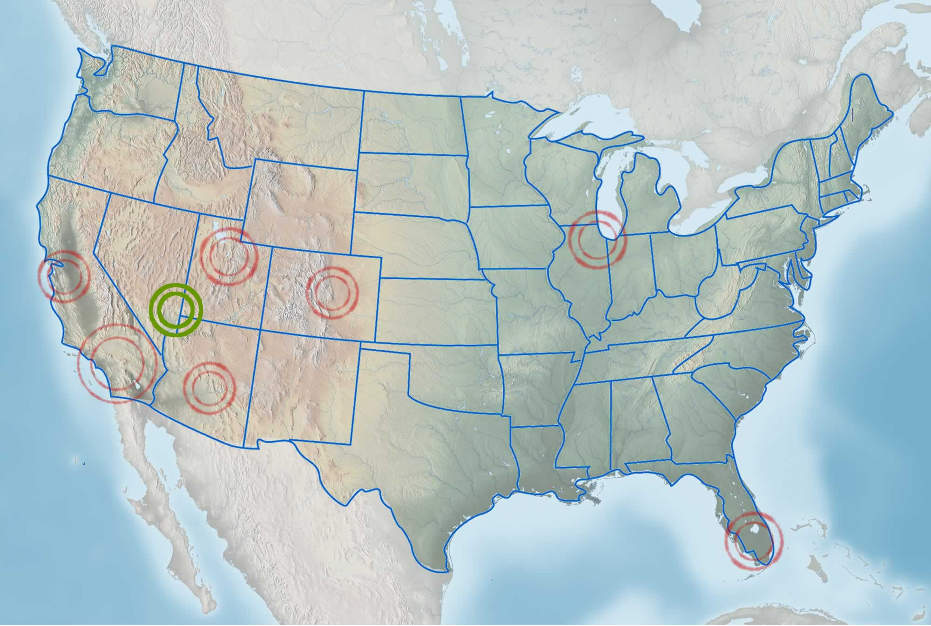

Coldwell Banker Premier, Las Vegas, NV (Proof site)
Management:
Robert H. Hamrick
Chairman, CEO
To describe Bob Hamrick, people often use the following three words: Integrity. Charisma. Leadership. As Chairman and CEO of Coldwell Banker Premier Realty (CBPR), Hamrick brings these terms to life every day, leading one of the top producing real estate companies in the United States. He has become a spokesperson for the ever-changing real estate market in Las Vegas, often quoted in The Wall Street Journal, USA Today and countless others.

Hamrick started earning his stripes as a real estate leader in Southern Nevada at the tender age of 17. He then helped grow a 50 person office to 100 sales associates while maintaining multimillion dollar personal sales, all before his 21st birthday. He repeated his leadership accomplishments at another office in 1988, and then CBPR hired him in February of 1995 as Managing Broker of an office that soon became recognized as the “most improved office” for the entire 500-office Western Region.

Molly K. Hamrick
President, COO
As President and COO of Coldwell Banker Premier Realty (CBPR), Molly Hamrick oversees the day-to-day operations at the number 8th ranked Coldwell Banker Company in the country out of 1,200 companies nationwide. She provides leadership and direction to every department of the company. In 1998, Hamrick and her husband Bob acquired CBPR Las Vegas and have been instrumental in increasing the gross commission income from $7.9 million in 1997 to more than $25 million in 2008. The company is now ranked as the #1, #2 and #3 Coldwell Banker offices in Nevada. Hamrick’s ability to plan efficiently and seize opportunities as they arise is one of the main reasons for the steady growth.
Sue Kwasneski
Vice President, REO and Relocation Services
Sue Kwasneski has successfully marketed and closed thousands of REO and corporate owned properties since 1986. Her commitment to exhaustive research, quick and cost effective property rehab, accurate pricing, and effective communication have garnered a reputation for results. She earned her stripes running one of the most successful relocation departments in the country for Coldwell Banker Premier Realty. Her commitment to excellence earned Coldwell Banker Premier Realty the #1 position for Customer Service with Cartus, a company that controls over 50% of all relocation business in the United States. Kwasneski has assisted over 15,000 people relocate to Las Vegas working with over 95 companies throughout North America.

Kwasneski’s REO clients seek her assistance when others companies have failed to get the job done. They understand the importance of a single point of contact and dealing with a company who has the financial and manpower resources to accomplish the goal of a quick sale with as few hassles as possible. She is a stickler for detail employing the finest technology tools available to track and service her clients’ accounts.

Brian Krueger
Senior Vice President, Developer and Investment Services
With nearly 15 years of real estate industry experience, Brian Krueger brings a high level of energy and dedication that produces high performing teams. He has delivered more than $2 billion in sales primarily in high-density residential properties. As Senior Vice President of Investment Services for Coldwell Banker Premier Realty (CBPR), Krueger collaborates with lenders and investors to create seamless partnerships and achieve their objectives.

Krueger is responsible for enhancing the awareness of the CBPR brand, driving innovation to constantly improve operational efficiencies, delivering quality market research, establishing and maximizing relationships with strategic partners, supporting new business initiatives and facilitating the acquisition and disposition of distressed real estate assets.

The Company:
2008 sales volume: $737,240,274
Sales units: 3,797
Closed units: 2,735
Market share: 8%

Locally owned and operated by Bob & Molly Hamrick, Coldwell Banker Premier Realty (CBPR) has brokered real estate in the greater Las Vegas area for over 25 years and sets the industry standard for service and production. CBPR doesn’t pride itself on or intend to be the largest, just the area’s best brokerage with a highly skilled sales force of over 300 professionals, 40 full time support staff and 3 strategically placed offices. It is due to the excellence of its sales professionals and leadership that has earned CBPR the honor of being ranked the number 8 Coldwell Banker company in the nation out of over 1,200 companies, with each office individually ranking in the Top 100 offices out of over 2,300 nationwide (the largest office taking the number 2 spot). Locally, CBPR maintains one of the highest Per Person Productivities in addition to consistently earning a stellar 97% or higher Customer Satisfaction Rating for Service Excellence.

CBPR is the company of choice for the top relocation networks including Cartus and USAA and has a working resume deep with major players and organizations from the developers of CityCenter and Union Park to the corporate relocation of groups such as Celine Dion, Wyndham Resorts, Harrah’s Corporation and CarMax. Our experience straddles every segment of the real estate market including single family and attached residences, REO and short sale properties, high-rise and mid-rise developments, commercial transactions and selling investors who understand that Las Vegas is an incredible value for and equally incredible lifestyle.

Coldwell Banker, Salt Lake/Wasatch, Utah
Dan Christensen: Bio
Company: # Agents # Offices
Bio…

Coming Soon
Sotheby’s Fuller, Denver, CO
Management:

Scott Webber: President
Scott has been in real estate management since 1983. He owned and operated Coldwell Banker Premier real estate with offices in Salt Lake City, UT, Las Vegas, NV and Denver, CO. In 2000 he sold his company to Cendant’s National Realty Trust (NRT). With that he became 1 of NRT’s 5 regional VIPs. He recently acquired Fuller-Sotheby’s in Denver and Summit Sotheby’s in Utah.
Scott is a skilled operator who thoroughly understands real estate and managing a company

Dolores Mozer, CRP :
Dolores Mozer has been in the relocation industry for the past 25 years, working as Relocation Director in the Denver area, and also as National Account Sales Representative for two major moving companies.
For the past 5 years Dolores has been Director of Relocation Services for Fuller Towne & Country Properties, now Fuller Sotheby’s International Realty, serving the entire front range of the Denver area. Fuller Sotheby’s has four offices and 180 full-time agents.
Dolores works with many of the third party companies, as well as direct with some national accounts. She holds her CRP designation, as well as her Colorado Real Estate License. She is the current President of the Rocky Mountain Relocation Council.

Laura Demaree, Inventory Management Specialist
Laura Demaree, Fuller Sotheby's International Realty's Inventory Management Specialist, brings 2+ years of experience in the real estate industry. She has been with Fuller Sotheby's for the past two and a half years and currently holds a real estate license in the state of Colorado. She works in various areas of areas of the relocation department. She is very familiar with the relocation process from both sides. She moved often as a child and as an adult.
Laura manages all inventory properties, from the listing to the sales and closing of the property. She inspects, orders all maintenance for the vacant property, as well as any updates. She works with all licensed, bonded vendors. Laura is also responsible for the payment of all vendor bills and the billing process to the third parties.

Linda Roberts, a Certified Relocation Coordinator
Linda Roberts, a Certified Relocation Coordinator, has served the relocation industry for seven years at Fuller Sotheby's -and before that -four years with Relocation Resources, International. Prior to that, she worked as a mortgage coordinator for a Seattle bank.
By participating in regional and national relocation conventions, Linda has formed a strong network of real estate and relocation professionals. As relocation coordinator, she routinely communicates with corporate clients, transferees, real estate personnel and relocation companies.
She is responsible for assessing incoming referrals needs so that a compatible local real estate person is assigned responsibility for the client. She creates and maintains entries in local/national databases -to track progress; identify all participants in the move and to troubleshoot problems. Further, she assures an accurate audit trail of all financial aspects of the move culminating in disbursement of all funds at closing.
As required, Linda works with agents, contractors, utilities and suppliers to properly care for inventory properties.

The Company:
Company: # Agents 200 # Offices 4
2008 sales volume: $737,240,274
Sales units: 3,797
Closed units: 2,735
Market share: 8%

Fuller Sotheby's International Realty is Denver's premier Independent real estate company specializing in home sales and buyers. The Relocation Director, Dolores Mozer, has 25 years of experience in relocation as well as the management and sale of REO properties. We appreciate and meet the need for timely, accurate reports from experienced agents who offer innovative ideas to solve buyer and property challenges. The company has 180 brokers in four offices, which provide service for the entire metro area. The company consistently receives recognition from the Denver Board of Realtors as being a top producing office. Many of Denver's top Brokers are with Fuller Sotheby's International Realty.
Baird & Warner, Chicago, IL
Management:
Jennifer Alter Warden
President, Baird & Warner Residential Sales
Jennifer oversees Baird & Warner’s residential sales division along with marketing and technology. She also serves on the firm’s executive committee and spearheads its charitable initiative, the Baird & Warner Good Will Network.

With Baird & Warner since 1995, Jennifer has been responsible for launching the company’s home services, e-business, and title operations.

Richard Mundt
Vice President, Baird & Warner Business Development
Rich joined Baird & Warner in June 1999 as Relocation Director for Baird & Warner and was promoted to the position of Vice-President, Business Development in 2001. He is responsible for leading the Relocation Services, REO Asset Services, Referral Associates Network and Home Services divisions of Baird & Warner.

Rich previously served on both the Cendant and USAA Relocation Directors Advisory Councils. Rich obtained the prestigious CRP designation from the Employee Relocation Council in 1996. He is also a frequent speaker at Relocation and Real Estate events and conferences and continues to serve as a mentor to many brokers across the country.

Karen Larsen
Karen Larsen has been with Baird & Warner since 2001 as an Account Manager. She has 15+ years of account management experience, including five years vendor management in the Baird & Warner Home Services program, adding value and simplicity to the real estate experience for thousands of home buyers and sellers. She is a licensed broker, who also has practical field experience in the residential real estate market.

Karen displays a natural aptitude for problem solving and relationship building and has assembled a strong team of performance driven REO agents. Her project management insight allows for participation from all team members as well as continuous monitoring of tasks, ensuring deadlines are met which results in turn-key solutions for our REO clients.

Company
Volume 2008: $2,734,409,212
Units: 7,285
Marker Share: #2
For over 154 years, Baird & Warner has been the dominant force on the Chicagoland real estate scene, building a record of success, innovation and longevity unparalleled in the industry. Family owned and operated since 1855, Baird & Warner is one of the oldest residential real estate brokerages in the nation, and the last remaining independent of substantial size in Illinois. Baird & Warner's network of 26 branch offices services more than 300 communities throughout northeastern Illinois.

Baird & Warner has continued to remain fresh and relevant through five generations by periodically re-inventing its operations in response to dynamic changes in the marketplace and the lead of the consumer. Baird & Warner today operates as a complete family of services — with Residential Sales, Financial Services, Title Services and Home Services all under one roof — offering consumers one-stop shopping for all of their home-ownership needs.

Prudential California Realty, Southern California and Central Coast
Management:
Jon L. Cook
President and CEO
Widely known and respected for his business expertise and management coaching skills, Jon Cook draws on a distinguished background in real estate management as President and CEO of the largest company in the Prudential Real Estate International network.

Prior to assuming this position, Cook served as the firm’s Executive Vice President/ General Manager. Among the highlights of his tenure were recruiting a number of experienced managers for the firm’s flagship offices and collaborating with a group of agent-directors to spearhead the creation of the firm’s Luxury Properties Division, launched in August 2008.

Jon S. Clark
Senior Vice President of Business Development,
Jon’s primary responsibility as a Director of MEXCONNECT is the listing agreement between Prudential California Realty and the Loreto Bay Company.

Jon’s career in real estate started in 1977 where he grew to be a top agent in the company. He then partnered with his wife Claire to become a top team in the company. They were offered senior management positions which they accepted in 1992 and went on to be the only Directors in history to be honored with the top award in their profession from the two major relocation networks in the world. Jon has also been named National Asset Manager of the year three times.

Company:
Service area: Southern California and Central Coast

Prudential California Realty is Southern California’s leading Residential Real Estate Company with 58 office locations and 3,400 sales associates. In 2008 Prudential California represented over 16,000 transactions with 13 billion in sales volume.

Prudential California and its affiliated service companies; Pickford Escrow Company, HomeServices Lending and California Title Company are HomeServices of America companies, an affiliate of Berkshire Hathaway.
Keyes Realty, Southern Florida
Management:
Michael Pappas
President of The Keyes Company, a Miami-based real estate company with 26 offices in South Florida, 1400 associates and subsidiaries that include Keyes Mortgage a partnership with Wells Fargo and Keyes

Mike Pappas is active in the local community serving on numerous philanthropic and corporate boards. He is also currently past International Chairman of Young Presidents Organization, a world wide 300 chapter, 16,000 member business organization. He acts as an advisory board director of Trulia, The Real Estate Services of NAR (Big Broker Advisory Board) and a member of the Realty Alliance.

Eunice Buzard
Twenty-six years of experience in real estate sales, relocation and REOs. Memberships in Employee Relocation Council, Southeastern Region Relocation Council, Relocation Director’s Council. Holds a Florida real estate license and CRP designation. Joined Keyes in 2000, managing a staff that is responsible for all facets of eCommerce, broker to broker referrals, corporate relocation, inventory and REOs.

Jackie Cue
Twenty years of real estate experience, primarily in REO, both as an agent and later as a manager. Member of the NRBA for several years and regularly attends the REO Mac conferences.

The Company:
2008 Volume- $1.8 billion
Units – 7,200 units
Market Share- 5%
Since The Keyes Company’s (www.keyes.com) founding in 1926 in Miami, Florida, its team of professionals has cultivated a well-respected reputation for meeting the diverse real estate needs of families, investors and businesses owners. The remarkable longevity of this independently-owned family business is a testament to its performance and success within the full range of market conditions. Keyes’ network of offices, professional associates and strategic partnerships serve customers regionally, nationally and internationally.

The company consistently ranks among the Top 100 real estate companies in the country, as measured by both sales and transaction volume. Its network, Leading Real Estate Companies of the World®, is the largest organization of locally branded residential real estate firms, with 700 companies and 170,000 associates producing over $370 billion in annual home sales.

Intero Real Estate Services, San Francisco Bay area
Management:
Gino Blefari
Founder, President & CEO
Gino has more than 25 years of experience in real estate sales, development and management, from
branch offices to regional and national operations

Mr. Blefari began selling real estate in 1984 and for the next 14 years was a top-producing agent selling more than 50 homes per year. During this time, he excelled at three different positions: as an agent, a manager and a chief operating officer. As a manager at Contempo Realty in 1988, he quickly set out transforming the Cupertino office from the lowest producing branch into the company’s number one office. Soon after, Mr. Blefari was promoted to chief operating officer and a partner where he oversaw the daily operations of 18 Contempo offices and their respective branch managers. In 1997,

Contempo Realty was purchased by NRT (also know as Realogy), a nationwide real estate brokerage company, and soon after, Mr. Blefari was named president of the new Century 21 Seville Contempo Company, operating in the Northern California region. As president, he was credited with increasing the company's profits by 280% in his first year on the job.

By 2000, he not only had the top five offices in the region, he had seven of the top eleven offices within Century 21's 6,300 worldwide offices. With this success as chief operating officer Mr. Blefari, already an award-winning REALTOR now had proven his exceptional abilities. And in 2001, he was subsequently promoted to senior vice president of NRT, where he began working on a national level. In addition to his on-the-job mentoring, Mr. Blefari is a faculty member at De Anza College where he teaches real estate courses and is a former director of the National Association of REALTORS®.

Company:
2008 Volume- $2.8 billion
Units – 4053 units
Market Share- 17.1% in Santa Clara and 30.3% in San Benito
Founded in 2002 Intero Real Estate Services Inc. has quickly become one of the premier real estate brands.

Guided by principles of trust, respect, and integrity Intero’s founders embarked on a mission to change the face of real estate. Intero, an Italian word that means “entire” or “whole,” was the namesake of the founder’s philosophy of empowering people-clients, agents and employees-to achieve their dreams in all areas of their life. Their vision was to create a different kind of real estate company - a company that focused on more than corporate profits and selling houses, one that offered training, education and alternative support for its people, such as life coaching and health and fitness programs to help them grow into better individuals personally and professionally.
Doug Yeaman, a powerful motivator who has trained more than 140,000 professionals, is the founder of Quantum Management Systems. A highly respected management consultant, he is known for his ability to create people-effective systems and train and consult within organizations, enabling them to become highly productive.

