Expressing Your Write Stuff
The privilege of a lifetime is to be who you are.
~Joseph Campbell~
Don't ask yourself what the world needs, ask yourself what makes you come alive.
And then go do that. Because what the world most needs are people who have come alive.
~Howard Thurman~
God is not found in the soul by adding anything, but by a process of subtraction…..
God does not ask anything else except that you let yourself go and let God be God in you.
~Meister Eckhart~

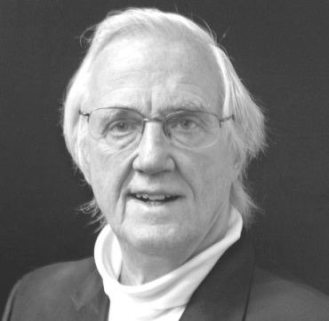
In four Saturday afternoon sessions, we explore a vibrant and refreshing new approach to self-communication and authorship, in a workshop that nurtures those who aspire to express themselves (and even publish) through the written word – an experiential essay, article, editorial, report, poem, journal, diary, song lyrics, personal correspondence, book, etc. The workshop's objective is to facilitate your greatest self-expression of your unique and as-only-you-can-say-it innermost message.
At the end of these four sessions, you will have taken command of your innermost becoming by
- Accessing your uniquely authentic inner voice,
- Clarifying its message, and
- Effectively expressing its message in thought and/or word and/or deed
The sessions are convened by Rev. Noel McInnis, at the Open Spirit Center for Spiritual Living, 10209 SE Division, Ste 3, Portland, 97266 (below and behind Blessings Bookstore), from 2-4 p.m. on Saturdays, Nov. 9, 16, 23 and Dec. 7 (skipping Thanksgiving weekend). Your self-investment: $45 (couples @ 2 for $75).

Expressing Your Write Stuff
The privilege of a lifetime is to be who you are.
~Joseph Campbell~
Don't ask yourself what the world needs, ask yourself what makes you come alive.
And then go do that. Because what the world most needs are people who have come alive.
~Howard Thurman~
God is not found in the soul by adding anything, but by a process of subtraction…..
God does not ask anything else except that you let yourself go and let God be God in you.
~Meister Eckhart~

In four Saturday afternoon sessions, we explore a vibrant and refreshing new approach to self-communication and authorship, in a workshop that nurtures those who aspire to express themselves (and even publish) through the written word – an experiential essay, article, editorial, report, poem, journal, diary, song lyrics, personal correspondence, book, etc. The workshop's objective is to facilitate your greatest self-expression of your unique and as-only-you-can-say-it innermost message.
At the end of these four sessions, you will have taken command of your innermost becoming by
- Accessing your uniquely authentic inner voice,
- Clarifying its message, and
- Effectively expressing its message in thought and/or word and/or deed
The sessions are convened by Rev. Noel McInnis, at the Open Spirit Center for Spiritual Living, 10209 SE Division, Ste 3, Portland, 97266 (below and behind Blessings Bookstore), from 2-4 p.m. on Saturdays, Nov. 9, 16, 23 and Dec. 7 (skipping Thanksgiving weekend). Your self-investment: $45 (couples @ 2 for $75).

