Expressing Your Write Stuff
The privilege of a lifetime is to be who you are.
~Joseph Campbell~
Don't ask yourself what the world needs, ask yourself what makes you come alive.
And then go do that. Because what the world most needs are people who have come alive.
~Howard Thurman~

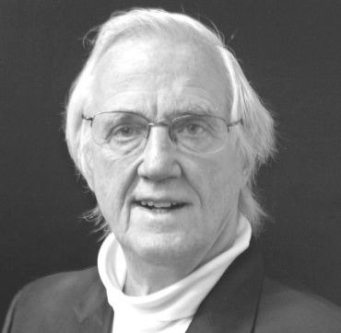
Enjoy four Saturday afternoon sessions of a vibrant and refreshing new come-alive approach to self-communication and authorship that nurtures your aspiration to express yourself in the written word (experiential essay, article, poetry, journal, diary, song lyrics, book, etc.). These sessions will facilitate the greatest self-expression of your very own unique and as-only-you-can-say-it innermost message, as well as its subsequent publication if you are so inclined.
During these sessions, you will take command of your innermost becoming by
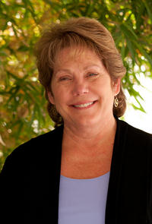
- Accessing your uniquely authentic inner voice,
- Clarifying its message, and
- Effectively expressing its message in thought and/or word and/or deed
The sessions are convened by Rev. Noel McInnis & Susan Buckley, from 2-4 p.m. on Saturdays Jan. 18, 25, Feb. 1, 8. at New Thought Center for Spiritual Living, 10th St. & C Ave., Lake Oswego. Your financial self-investment is $45 (couples @ 2 for $75). Your spiritual investment is unlimited, as invited on the back of this announcement

Expressing Your Write Stuff
The privilege of a lifetime is to be who you are.
~Joseph Campbell~
Don't ask yourself what the world needs, ask yourself what makes you come alive.
And then go do that. Because what the world most needs are people who have come alive.
~Howard Thurman~

Enjoy four Saturday afternoon sessions of a vibrant and refreshing new come-alive approach to self-communication and authorship that nurtures your aspiration to express yourself in the written word (experiential essay, article, poetry, journal, diary, song lyrics, book, etc.). These sessions will facilitate the greatest self-expression of your very own unique and as-only-you-can-say-it innermost message, as well as its subsequent publication if you are so inclined.
During these sessions, you will take command of your innermost becoming by
- Accessing your uniquely authentic inner voice,
- Clarifying its message, and
- Effectively expressing its message in thought and/or word and/or deed
The sessions are convened by Rev. Noel McInnis & Susan Buckley, from 2-4 p.m. on Saturdays Jan. 18, 25, Feb. 1, 8. at New Thought Center for Spiritual Living, 10th St. & C Ave., Lake Oswego. Your financial self-investment is $45 (couples @ 2 for $75). Your spiritual investment is unlimited, as invited on the back of this announcement.

INVITATION
It doesn't interest me what you do for a living. I want to know what you ache for, and if you dare to dream of meeting your heart's longing.
It doesn't interest me how old you are. I want to know if you will risk looking like a fool for love, for your dreams, for the adventure of being alive.
It doesn't interest me what planets are squaring your moon. I want to know if you have touched the center of your own sorrow. If you have been opened by life's betrayals or have become shriveled and closed from fear of further pain!
I want to know if you can sit with pain, mine or your own, without moving to hide it or fade it or fix it. I want to know if you can be with joy, mine or your own; if you can dance with wildness and let the ecstasy fill you to the tips of your fingers and toes without cautioning us to be careful.
It doesn't interest me if the story you are telling me is true, I want to know if you can disappoint another to be true to yourself, be realistic, or to remember the limitations of being human, if you can bear the accusation of betrayal and not betray your own soul. I want to know if you can be faithful and therefore trustworthy. I want to know if you can see beauty, even when it is not pretty every day, and if you can live with failure, yours or mine, and still stand on the edge of a lake and shout to the silver of the full moon, "Yes!".
It doesn't interest me to know where you live or how much money you have. I want to know if you can get up after a night of grief and despair, weary and bruised to the bone, and do what needs to be done for the children.
It doesn't interest me who you are, how you came to be here. I want to know if you will stand in the center of the fire with me and not shrink back.
It doesn't interest me where or what or with whom you have studied. I want to know what sustains you from the inside when all else falls away. I want to know if you have to be alone with yourself, can you truly like the company you keep in the empty moments? ~Oriah Mountain Dreamer, Indian Elder~

INVITATION
It doesn't interest me what you do for a living. I want to know what you ache for, and if you dare to dream of meeting your heart's longing.
It doesn't interest me how old you are. I want to know if you will risk looking like a fool for love, for your dreams, for the adventure of being alive.
It doesn't interest me what planets are squaring your moon. I want to know if you have touched the center of your own sorrow. If you have been opened by life's betrayals or have become shriveled and closed from fear of further pain!
I want to know if you can sit with pain, mine or your own, without moving to hide it or fade it or fix it. I want to know if you can be with joy, mine or your own; if you can dance with wildness and let the ecstasy fill you to the tips of your fingers and toes without cautioning us to be careful.
It doesn't interest me if the story you are telling me is true, I want to know if you can disappoint another to be true to yourself, be realistic, or to remember the limitations of being human, if you can bear the accusation of betrayal and not betray your own soul. I want to know if you can be faithful and therefore trustworthy. I want to know if you can see beauty, even when it is not pretty every day, and if you can live with failure, yours or mine, and still stand on the edge of a lake and shout to the silver of the full moon, "Yes!".
It doesn't interest me to know where you live or how much money you have. I want to know if you can get up after a night of grief and despair, weary and bruised to the bone, and do what needs to be done for the children.
It doesn't interest me who you are, how you came to be here. I want to know if you will stand in the center of the fire with me and not shrink back.
It doesn't interest me where or what or with whom you have studied. I want to know what sustains you from the inside when all else falls away. I want to know if you have to be alone with yourself, can you truly like the company you keep in the empty moments? ~Oriah Mountain Dreamer, Indian Elder~

