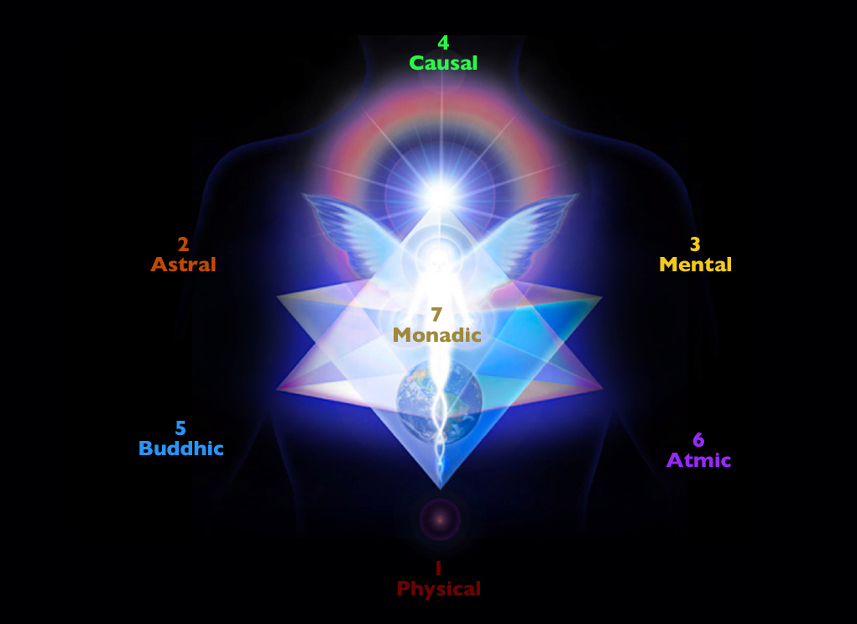

CORPUS CHRISTI & RAINBOW BODY

by Teresa Collins

