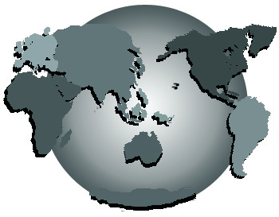
Piecing Together a Better World
via the power and practice of collaboration
9/24/2005 at the Oregon Convention Center
Duane Elgin ~ Peter Russell, ~ David Spangler ~ Donna Zajonc
Featuring practices, projects, and programs
of collaborative, non-adversarial advocacy
for well-being, peace and environmental integrity.
Full details: www.gbenetwork.com

