Piecing Together | 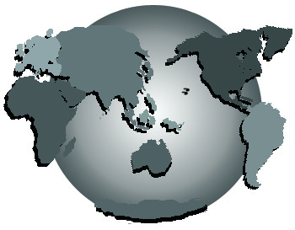 | a Better World

Name:

Address:

City & State:

Phone #(s):

E-mail Address:

