Networking Our Global Brain

Piecing Together a Better World is an interactive gathering of over 2000 participants who are committed to personal and planetary well-being, peace, and environmental integrity. We are gathering to devise collaborative initiatives for coherent, unified transformational action.
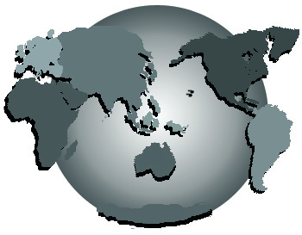

~CONFERENCE KEYNOTE CONSULTANTS~
PETER RUSSELL: Awakening Our Global Brain in Time
DUANE ELGIN: Embracing the Adulthood of Our Species
DONNA ZAJONC: Collaboration: The Bridge from Diversity to Inclusivity
DAVID SPANGLER: Inner Citizenship: Engaging the Soul of America

Full information on the conference is at www.gbenetwork.com. Its program is a work in progress designed in consultation with thousands of persons who attend free, interactive pre-conference briefings throughout the Pacific Northwest. Briefings are listed on the website, including information on how to schedule and/or conduct your own local briefing.

Admission to the conference is free, and is limited to persons enrolled as Associates in its sponsoring organization, the Global Brain Empowerment Network.* You may enroll as a GBEN Associate on the website, or via the adjacent form accompanied by a $36 check payable to “GBEN”.

*NOTE: An additional donation will be requested of everyone who attends the conference, to fund GBEN’s ongoing initiatives.

