Piecing Together | 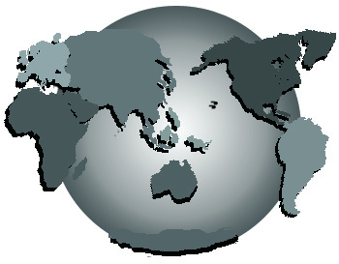 | a Better World
Sponsored by the Global Brain Empowerment Network
September 24, 2005, 9 a.m. – 9 p.m.
Oregon Convention Center

The power and practice of collaborative, non-adversarial advocacy

Dear Mr. Hartmann,

I am the former editor of Marilyn Ferguson’s Brain/Mind Bulletin and of Barbara Marx Hubbard’s Book of Co-Creation, who spoke with you briefly at the Dennis Kucinich event about the above conference.

You gave me your card and instructed me to call and speak with Paul, to arrange for an appearance on your Portland radio show.

If possible, I would like to be joined by Sharif Abdullah, local author of Creating a World that Works for Everyone, whose work will be a major feature on the program.

Sharif’s websites are http://www.common-society.org and http://www.commonway.org.

I will be calling Paul soon to arrange for an August guest appearance.

In the meantime, enclosed are contextual materials concerning the conference.

Stay in the grace!

Noel McInnis

Global Brain Empowerment Network
8855 SW Holly Lane, Suite 111, Wilsonville, OR 97070
briefings@gbenetwork.com ~ 503/570-4331

