Is Humanity Growing Up?
By Duane Elgin, adapted from his book Promise Ahead

Life is occupied in both perpetuating itself and in surpassing itself;
if all it does is maintain itself, then living is only not dying.
-Simone de Beauvoir

Humanity’s Age
How grown up do you think humanity is? When you look at human behavior around the world and then imagine our species as one individual, how old would that person be? A toddler? A teenager? A young adult? An elder?
As I’ve traveled in different parts of the world, speaking to diverse audiences, I’ve begun many of my presentations by asking this question. Initially, I didn’t know whether people would be able to relate to or even understand my question, much less agree on an answer. To my surprise, nearly everyone I’ve asked has understood this question immediately and has had an intuitive sense of the human family’s level of maturity. Whether I’ve asked this question in the United States, England, India, Japan, or Brazil, within seconds people have responded in the same way: at least two-thirds say that humanity is in its teenage years.
The speed and consistency with which different groups around the world have come to this intuitive conclusion were so striking that I began to explore adolescent psychology. I quickly discovered that there are many parallels between humanity’s current behavior and that of teenagers:
• Teenagers are rebellious and want to prove their independence. Humanity has been rebelling against nature for thousands of years, trying to prove that we are independent from it.
• Teenagers are reckless and tend to live without regard for the consequences of their behavior. The human family has been acting recklessly in consuming natural resources as if they would last forever; polluting the air, water, and land of the planet; and exterminating a significant part of animal and plant life on the Earth.
• Teenagers are concerned with appearance and with fitting in. Similarly, many humans seem focused on expressing their identity and status through material possessions.
• Teenagers are drawn toward instant gratification. As a species, we are seeking our own pleasures and largely ignoring the needs of other species and future generations.
• Teenagers tend to gather in groups or cliques, and often express “us versus them” and “in versus out” thinking and behavior. We are often clustered into ethnic, racial, religious, and other groupings that separate us from one another, making an “us versus them” mentality widespread in today’s world.
Other authors have noted that we are acting like teenagers. Al Gore wrote in his book Earth in the Balance, “The metaphor is irresistible: a civilization that has, like an adolescent, acquired new powers but not the maturity to use them wisely also runs the risk of an unrealistic sense of immortality and a dulled perception of serious danger. . . .” In a similar vein, Allen Hammond, senior scientist at the World Resources Institute, who has been exploring the world of 2050, has written, “Just as parents struggle to teach their children to think ahead, to choose a future and not just drift through life, it is high time that human society as a whole learns to do the same.”
If people around the world are accurate in their assessment that the human family has entered its adolescence, that could explain much about humanity’s current behavior, and could give us hope for the future. It is promising to consider the possibility that human beings may not be far from a new level of maturity. If we do develop beyond our adolescence, our species could begin to behave as teenagers around the world do when they move into early adulthood: we could begin to settle down, think about building a family, look for meaningful work, and make longer-range plans for the future.
Adolescence is a time when others—such as parents, schools, churches, and so on—are generally in control. As we step into adulthood, we enjoy a new freedom from control, and a new responsibility to take charge of our lives. In a similar way, during our adolescence as citizens of the Earth, most humans have felt controlled by someone else—especially by big institutions of business, government, religion and the media. As we grow into our early adulthood as a species, we will discover that maturity requires taking more responsibility and recognizing that we are in charge. Instead of waiting for “mom or dad to fix things,” an adult is one who pays attention to the larger situation and then acts, recognizing that our personal and collective success are deeply intertwined.
Is it plausible that humanity is truly on the verge of moving beyond our adolescence? Not only do I consider it plausible, I would like to offer a rough timetable for the maturing of humanity. I estimate that we awoke in the infancy of our potentials roughly 35,000 years ago. Archeologists have found that, at that time, there was a virtual explosion of sophisticated stone tools, elaborate burials, personal ornaments, and cave paintings. Then, with the end of the ice ages roughly 10,000 years ago, we began to settle down in small, farming villages. I believe this period marks the transition to humanity’s childhood. The food surplus that peasants produced made possible the eventual rise of small cities. I estimate we humans then moved into our late childhood with the rise of city-state civilizations roughly 5,000 years ago in the Iraq, Egypt, India, China, and the Americas. At that time, all the basic arts of civilization were developed, such as writing, mathematics, astronomy, civil codes, and central government. Still, the vast majority of people lived as impoverished and illiterate peasants who had no expectation of material progress. With the scientific-industrial revolution roughly 300 years ago, humanity began to move into our adolescence. Beginning in Europe and the U.S., industrialization has spread around the world, particularly in the last half-century. Now, with the industrial revolution impacting the whole planet and challenging humanity to a new level of stewardship, it seems plausible that we are on the verge of moving into the communications era and our early adulthood.
This timetable gives only a rough estimate of the average level of maturity of our species, but it does make an important point: that human beings are growing up, becoming more seasoned and wiser through hard-earned experience. Despite humanity’s seeming immaturity in the past, I believe we could be close—within a few decades—of taking a major step forward in our evolution as a species.
Humanity’s Heroic Journey of Awakening
If we look beneath the complexity of human history and culture, there seems to be a story that humanity shares regarding the purpose of life. Joseph Campbell, a world-renowned scholar who spent a lifetime exploring the stories that have brought meaning to people throughout history, described the common story at the heart of all the world’s cultures as the “hero’s journey.” Although the details vary depending on where and when it has been told, it is essentially the story of an individual who grows up by going through a series of tests that teach him or her about the nature of life. The person then brings this precious knowledge back to his or her personal life and life of the community.
If we assume that the overall human family is on an heroic journey of development, then the pivotal question becomes, “where are we on the hero’s journey?” To explore that key question, it is important to know that the hero’s journey usually consists of three stages: separation, initiation, and return. It begins with the hero (or heroine) leaving home to search for the deeper meaning and purpose of life. This is the stage of separation. There eventually comes when the hero undergoes a supreme test, whereby he is initiated into the nature and ways of the universe and no longer feels separate. With initiation, he experiences the deep unity and aliveness at the foundation of the universe and his sense of life-purpose in relation to it. He returns from his adventure with that hard-won knowledge and the capacity for personal renewal or even, says Campbell, “the means for the regeneration of society.” The core purpose of that sacred knowledge, according to Campbell, is to “waken and maintain in the individual a sense of wonder and participation in the mystery of this finally inscrutable universe.”
Just as all major cultures share the story of the hero’s journey, all have customs of initiation as well. Initiatory rites of passage around the world have at least two things in common. First, for the individual, the initiation marks a decisive transition from one stage or kind of life to another (such as from adolescence to adulthood). Second, initiation rites are also stressful social situations in which new ways of relating to other people are learned and established. The experience of initiation forges bonds of connection among those who have gone through it, bonds that transcend previous distinctions based on status, age, or kinship. Long after the rites are concluded, these links and emotional bonds persist and provide much of the social glue that holds the community together.
Let’s look at humanity’s journey in terms of this simple model of separation, initiation, and return.
• Separation—By my reckoning, a complex phase of progressively divorcing ourselves from nature has extended over the last 35,000 years—from the time of our initial awakening as gatherers and hunters up to the present. During these millennia, humanity has increasingly pulled away from nature in order to develop our unique capacities and talents as a species. The last half-century seems to mark our final severance from nature as we cause, for example, the mass extinction of other species and the disruption of the global climate.
• Initiation—To undergo initiation is to make a major transition to a new and larger life, and it often involves going through a powerful experience. As we confront challenges such as climate change, species extinction, humanity seems poised to undergo an initiation, which will give us the opportunity of becoming an authentic human family—in feeling and experience as well as in name.
• Return—To pass successfully through our initiation, we will have to forge new bonds both within our species and with nature as a whole. This phase marks our passage into our early adulthood and the beginning of a long process of reconnecting with nature. A promising future lies ahead as we begin a task for grown-ups—building a sustainable planetary civilization.
When we view humanity’s evolution this way, our times take on new significance. Humanity is about to move into a stage of initiation—a period of stress and testing in which we will be challenged to discover ourselves as a single family with responsibilities to one another, the Earth, and future generations. Although the challenges we face may seem to be evidence of humanity’s failures, reaching this stage is actually an expression of our great success over the past 35,000 years. I believe that the apparent crises we face are, in reality, part of our initiation into a new relationship with one another and the Earth, a fusion of our unique capabilities with those of nature. The rapidly approaching initiation represents a time of birth—a stressful but entirely natural process.
When we began our journey of awakening roughly 35,000 years ago, we had only an indistinct sense of ourselves and a strong but largely unconscious feeling of connection with nature. Over the millennia, we have acquired a strong sense of ourselves, but at the cost of separating ourselves from nature. Looking ahead, we have the opportunity to reconnect consciously with nature and the larger human family. As in the hero’s journey, our challenge is to return to where we started, but with a new level of insight, compassion, and creativity. T.S. Eliot foretold of this return when he wrote “And the end of all our exploring Will be to arrive where we started And know the place for the first time.”
Figure 1 illustrates this description of our evolutionary journey as separating from and then reconnecting with nature. It is important to note that there is no negative implication in the downward direction of the first arrow. Its purpose is simply to show that we pulled away from nature. We shall soon enter a period of initiation, in which we see that we have a choice of connecting consciously with nature and the universe. Making the transition from separation to integration, without losing the scientific understanding and technical sophistication we have gained, is perhaps the most important evolutionary turn that humanity will ever have to accomplish.
Figure 1: Two Major Phases in the Human Journey
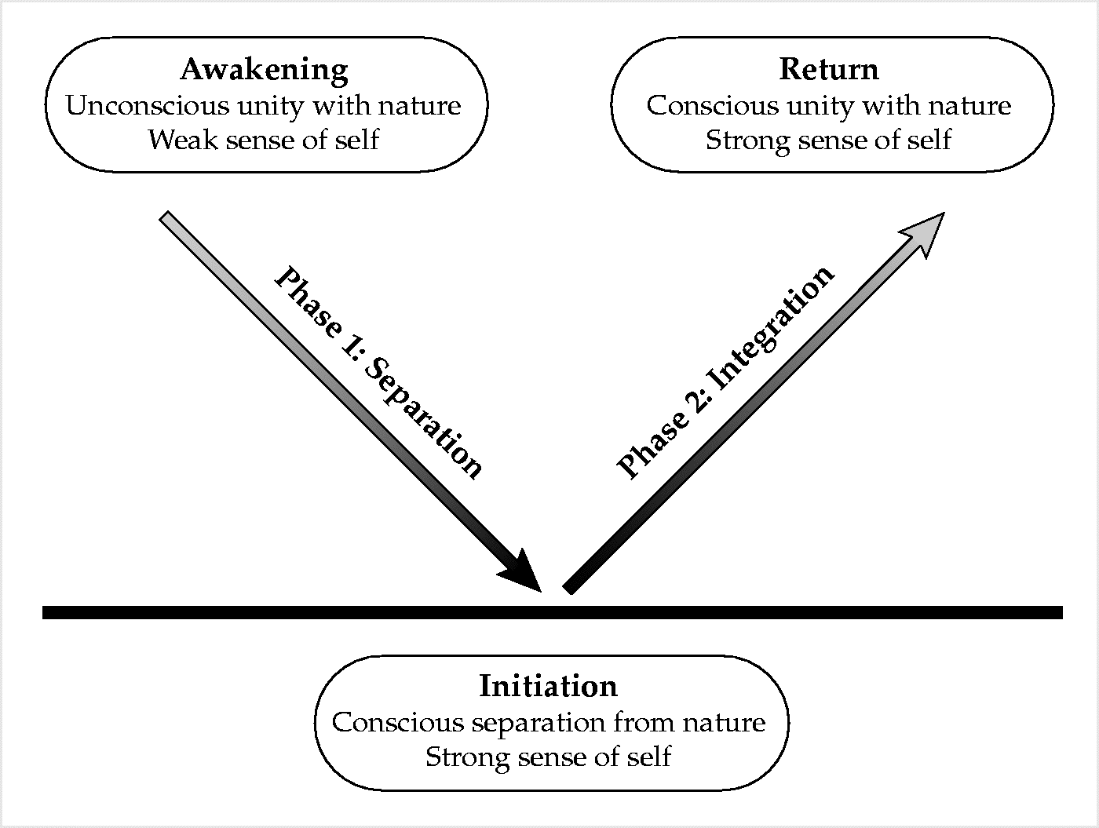

Initiation: Hitting the Evolutionary Wall
Here is how William D. Ruckelshaus, the former director of the Environmental Protection Agency, describes the evolutionary task that we are facing:
Can we move nations and people in the direction of sustainability? Such a move would be a modification of society comparable in scale to only two other changes: the Agricultural Revolution and the Industrial Revolution of the past two centuries. Those revolutions were gradual, spontaneous, and largely unconscious. This one will have to be a fully conscious operation . . . . If we actually do it, the undertaking will be absolutely unique in humanity’s stay on the Earth.
What would motivate us to attempt such an undertaking? I believe it will take both the push of environmental necessity and the pull of evolutionary opportunity for humanity to attempt to overcome 35,000 years of progressive separation from nature and discover how to live in conscious harmony with one another and the Earth. Like adolescents pressing to find the limits of their parents’ authority, we are pushing up against the limits of nature, as though seeking to discover just how much abuse our planet will tolerate. But we face much more than physical problems; we face equally great challenges in our own consciousness and character. The historic path of development is being confronted, not only with an environmental wall, but by an even more formidable evolutionary wall. It would be useful to distinguish here between the two:
• An environmental wall refers to the physical limits of the global ecosystem to support our species. We are fast approaching these limits because we are rapidly consuming more resources than the Earth can renew and polluting the environment with more than it can absorb. Given an abundance of resources, nearly every organism exploits its environmental niche to the fullest extent; thus, overshoot and collapse are a common occurrence in natural systems. Human beings learn through experience, and we have no experience exercising restraint as a species and being mindful of the overall biosphere. Since we have never encountered this situation before, it seems only natural that humanity would reach, and then extend beyond, the limits of the Earth’s ecosystem.
• An evolutionary wall refers not only to the physical limits of the Earth’s ability to sustain humanity, but also to our own social and spiritual limits to sustain dysfunctional and destructive behaviors. Modern, industrial civilization is breeding pathological behavior—alienation from others and from nature, extreme competitiveness and greed, cynicism in politics, and despair for the future. How much poverty, alienation, and misery can humanity experience before we eventually damage our collective psyche and soul? An evolutionary wall presents humanity with an identity crisis at least as great as our environmental crisis: Who are we as a species? What is our larger story? Are we going to allow “overshoot and collapse” to happen to us? Do we see ourselves as separate, isolated beings or part of the larger web of life?
In seeing the initiation that awaits us, it is clear that we have come to a great choice-point in our journey. Although human beings have been faced with challenges throughout history, we have never before been confronted with a challenge to our entire planet and species. Our time is unique in one crucial respect: the circle has closed—there is nowhere to escape. For the first time in our history, the entire human population is confronted with a common predicament whose solution will require us to work together.
It is vital that we look beyond the possibility of a destructive evolutionary crash to the possibility of an evolutionary bounce. I believe that in the coming decades, there is the distinct possibility that we may surpass ourselves and evolve to a level of maturity that we could not attain without confronting these trials that I am calling “initiation.” How might an evolutionary bounce look? I see it as a leap forward in our collective maturity to build a life together that would be harmonious in three ways. It would be:
• Sustainable—in harmony with the Earth's biosphere (the physical ecosystem)
• Satisfying—in harmony with others (the social-cultural ecosystem)
• Soulful—in harmony with the “life force” (the spiritual ecosystem).
There are two compelling reasons for making this evolutionary turn. First, it is eminently desirable and will lead to a higher quality of life for all. Second, it is necessary if we are to avoid creating a planet that is hotter, hungrier, poorer, and more polluted, diseased, and biologically impoverished than it already is.
Humanity’s Promising Future
If we do get through these difficult times and grow into our early adulthood as a species, how long might we then survive? We can gain some perspective by looking at the longevity of early humans and other animal species. The typical life span of a species is estimated to be between one and 10 million years. For example, our early ancestor Homo erectus survived more than a million years before becoming extinct. Some species live far longer. Dinosaurs survived roughly 140 million years before a natural catastrophe wiped them out. If humanity is as capable of survival as the dinosaurs were, our species would be able to endure for more than 25,000 times the span of recorded human history. If we can make it through this evolutionary initiation and begin building a sustainable, satisfying, and soulful planetary civilization, we have the prospect of a long and promising future.
Just as every child makes missteps on the path to adulthood, humanity has made and will continue to make painful mistakes as we evolve. We learn through our mistakes, however, and we keep moving ahead step by step. We are ever more experienced, ever more seasoned, and ever more mature. Although our future is uncertain, we already have the resources and capacities we need for success. The biologist Lewis Thomas describes the promise of our species beautifully:
We may all be going through a kind of childhood in the evolution of our kind of animal. . . . If we can stay alive, my guess is that we will someday amaze ourselves by what we can become as a species. Looked at as larvae, even as juveniles, for all our folly, we are a splendid, promising form of life and I am on our side.
I too believe that humanity has a promising future. The word promise has its origin in the French word promittere which means “to send forth.” A promise, then, is a sending forth of a declaration, vow, pledge, or commitment. I believe we are reaching a unique point in our evolution where we can make a promise to future generations. It is a declaration that we will not forget them in the rush and busyness of our day-to-day lives. The promise is our marriage with the larger flow of life—both past and future—and our recognition that we are now a critical link in maintaining the integrity of that flow. It is our sacred covenant with the future whereby we send ahead not only our good intentions, but also our commitment of active engagement to turn the direction of our evolution in favor of a promising future. It is our vow to future generations that we shall hold them in our hearts and minds as we make decisions, recognizing that we all share the same Earth and a common journey through eternity.

Al Gore, Earth in the Balance, New York: Houghton Mifflin Co., 1992, p. 213.
Allen Hammond, “Three Global Scenarios: Choosing the World We Want,” The Futurist, Bethesda, MD, April 1999, p. 43.
Joseph Campbell, The Hero with a Thousand Faces, New York: Meridian Book Edition, 1956, p. 30.
Ibid, p. 37.
Peter Farb, Humankind, Boston: Houghton Mifflin Co., 1978, p. 431.
Ibid, p. 432.
Barbara Hubbard, Conscious Evolution, Novato, CA: New World Library, 1998.
See Chapter Two of my book, Awakening Earth, New York: William Morrow, 1993.
T. S. Eliot, Four Quartets, New York: Harcourt & Brace, 1943.
William D. Ruckelshaus, “Toward a Sustainable World,” Scientific American, September 1989, p. 167.
Elizabeth Dowdeswell, “Lessons Learned in Sustainable Development,” from a speech, 1998.
Kevin Kelly, “Deep Evolution: The Emergence of Postdarwinism,” Whole Earth Review, Sausalito, California, Fall 1992, p. 15.
Lewis Thomas, The Fragile Species, New York: Macmillan, 1992

