Science Made Simple
Stephen Cherniske, MS

Five things you absolutely must know!

First thing you must absolutely know…

Healthy Aging is accomplished in Three Stages.

STAGE 1
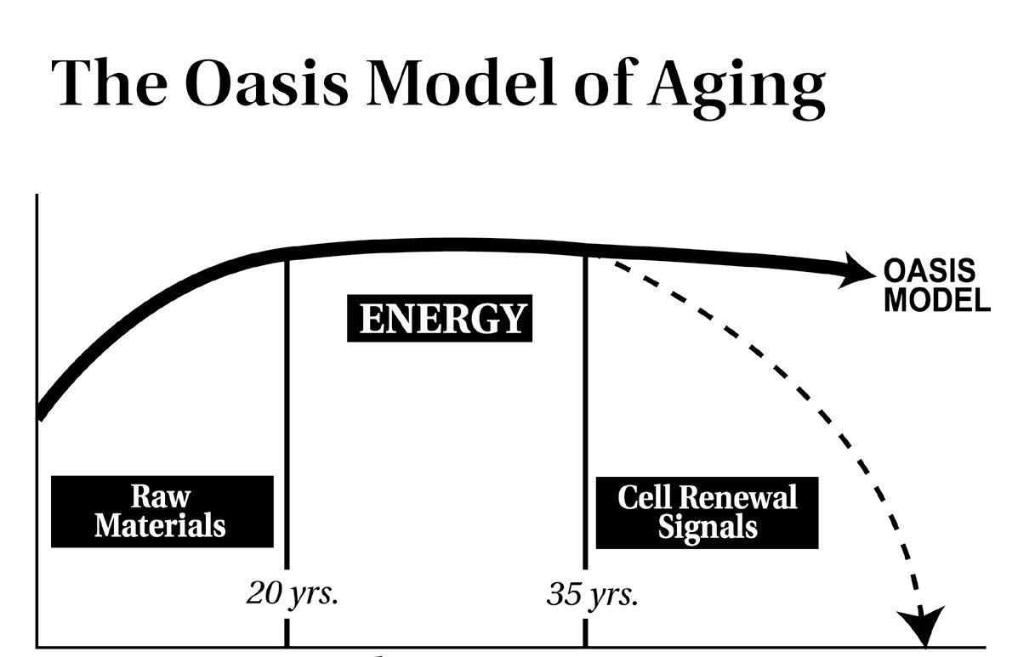
Primary need for Raw Materials for Optimal Growth & Development
Core Product: Ageless Essentials

STAGE 2
Repair becomes the critical activity, requires energy and thus in Stage 2, energy becomes a significant limiting factor.
Core Product: Ageless Xtra

STAGE 3
Raw Materials & Energy are not enough. Biochemical repair signals from hormones such as DHEA become a limiting factor.
Core Product: Ageless Prime

Second thing you must absolutely know…

At each stage, quality of life is a see-saw.
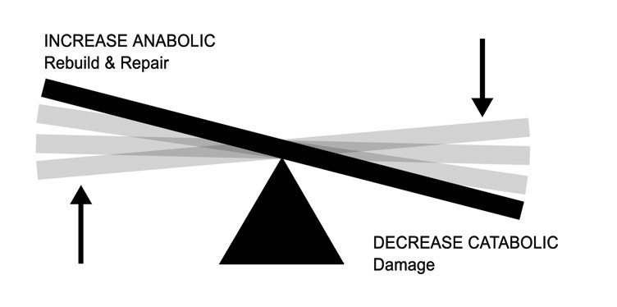
- On one side is all the damage you experience at the cellular level
- On the other side is your ability to repair and regenerate.
- As damage accumulates and repair falters, the symptoms of aging appear.

The third thing you must absolutely know…
This is done by reducing damage and supporting repair & regenerating activity on a daily basis. If you do not do this, you will experience aging like the average person.

You can tip the see-saw in your favor!
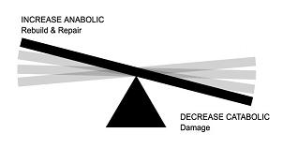

Fourth thing you must absolutely know…
“Average” is nothing to aspire to!

Average people
- Have a prime of life that only lasts about 15 years
- Start to experience significant degeneration at age 40
- By 50, have progressed to acquire 1 or more chronic conditions
- 65 years of age are on a SIX prescription drugs
- Degenerate seriously in their 60’s and Average American dies before their 78th birthday

Fifth thing you must absolutely know…
OASIS products and programs:
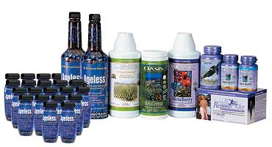
Oasis products and programs enable people to dramatically alter the way in which they experience the aging process.
This promise is back by a New Customer 90-Day Money-Back Guarantee.
Both the benefits and the guarantee are unmatched in the natural products industry.

Now absolutely know! What will you do?

