The Science of Causing Outcomes:
Managing from the Heart of the Matter
Douglas Yeaman and Noel Frederick McInnis
Experience is not what happens to us,
it is rather what we do with what happens to us.
–Aldous Huxley
One morning when single parent Susan Bradford entered her kitchen to make breakfast for herself and her three-year-old daughter, Amanda, she found the child lying semi-conscious on the floor. Amanda had been awakened by a now receding storm, and had come to the kitchen to play. An open, empty pill bottle lying beside her told the rest of the story.
Susan quickly read the bottle’s label, which warned that death from an overdose could occur within half an hour of loss of consciousness. Though Susan was still dressed in her negligee and her hair was in curlers, she scooped Amanda into her arms with the empty bottle in hand, and ran to her car.
When the car would not start, Susan dashed back to the house to call a neighbor. The phone line was dead, as service had been disrupted by a fallen tree. Rather than lose precious time by going to her neighbor’s house, Susan raced back to the car, grabbed her now unconscious child, and ran to the nearby freeway. Despite being so scantily clad, she was unconcerned about either the chilling wind or her semi-naked appearance. She stepped onto the freeway to wave down a car, and immediately got a ride. Amanda was at the nearest hospital emergency room in just a few minutes.
Susan Bradford’s masterful demonstration of the science of causing outcomes stands in stark contrast to the two million persons who undergo coronary bypasses and angioplasties each year, in spite of which only one in nine of them subsequently makes lifestyle changes consistent with maintaining a healthy heart. Those who are fortunate not to have a heart attack before another intervention is required must undergo yet another bypass or angioplasty, and in many cases a continued series thereof.
Why do some people act consistently with their self-interest, as Susan Bradford did, while so many others do not? Why do some people manage to cause positive outcomes, while others persist in causing outcomes that are inconsistent with and often directly contrary to their deepest self-interest? Why, when the science of causing outcomes is the same for everyone, do so many apply it dysfunctionally? What accounts for the success of those who choose to cause self-empowering and life-enhancing outcomes? And how may those who are committed to life-diminishing outcomes be empowered to cause life-enhancing outcomes instead?
Answering these questions requires us to understand how the science of causing outcomes works. This understanding begins with the realization that every outcome is caused, that all self-outcomes are self-caused, and that every person is at all times causing his or her own outcomes, whether consciously or unconsciously. With this comes the realization that all causation of outcomes is from within, which means that all power of causation is within. The potency of this latter realization was cited by Rudolph Steiner:
If it depends on something other than myself whether I should get angry or not, I am not master of myself . . . I have not yet found the ruler within myself. I must develop the faculty of letting the impressions of the outer world approach me only in the way in which I myself determine.
It seldom occurs to most of us that we have the power of inner sovereignty to determine how the impressions of the outer world approach us. Yet this is precisely how Susan Bradford arrived at the ER in time to save her daughter’s life, as evidenced in her answer to the question of what went through her mind as she read the warning label on the empty pill bottle. “I saw myself in the emergency room with Amanda,” she replied. Thus guided by her intention of being in the ER, she never entertained the thought of not getting there in time. Nondivertibly programmed with her projected outcome, her mindset moved her to take every possible step until the outcome was accomplished. She managed her journey to the ER from her projected outcome of already being there. Her trajectory was managed from the perspective of its successful accomplishment.
Had Susan’s mind instead been set on getting to the ER, rather than on being there, the stalled vehicle and dead phone might have impeded her progress with persistent attempts to start the car or to reach a neighbor. It was her mindset of already being at the ER that got her there so efficiently and effectively in spite of all impediment to her doing so. It was the accomplished presence-in-mind of her projected outcome – the state of already being at the ER in her own mind’s eye – that assured her getting there while sensitizing her to every pertinent detail, such as carrying in her purse the pill bottle required to inform the ER doctors.
When Susan was further asked during one of our life-management trainings what she would have done had passing motorists ignored her, she declared, “I’d have undressed and laid down naked on the freeway – or whatever else it took – until someone did stop.” Her imagination of being at the ER prevailed over all impressionability by circumstance. By thus exercising her inner sovereignty, she succeeded in making the outer world’s impressions approach her in the way that she herself determined.
Reality Is an Inside Job
We don’t see things as they are.
We see things as we are.
-The Talmud
Our access to the “inner ruler” of which Rudolph Steiner spoke is via our faculty of perception, which is susceptible, as integral psychologist Ken Wilber warns, to what he calls “the myth of the given.” This “myth” is our belief that the world as it appears in our consciousness is the equivalent of the real thing, even though what our awareness delivers to us is embedded in cultural, linguistic and other contexts that structure our perceptions accordingly before they’ve even reached our awareness. Accordingly, “what we call real or what we think of as given is actually constructed.”
Nineteenth century American humorist Artemus Ward acknowledged the impact of our self-constructed givens in his proclamation that “It ain't so much the things you don't know that get you in trouble. It's the things you know that just ain't so.” Our ability to perceive things that “just ain’t so” is revealed by optical illusions like the one we offer below, which may be examined more closely in light of an accompanying neuroscientific explanation of its equivocal dynamics, on the website of its creator, MIT Vision Science Professor Edward H. Adelson (http://web.mit.edu/persci/people/adelson/checkershadow_illusion.html).

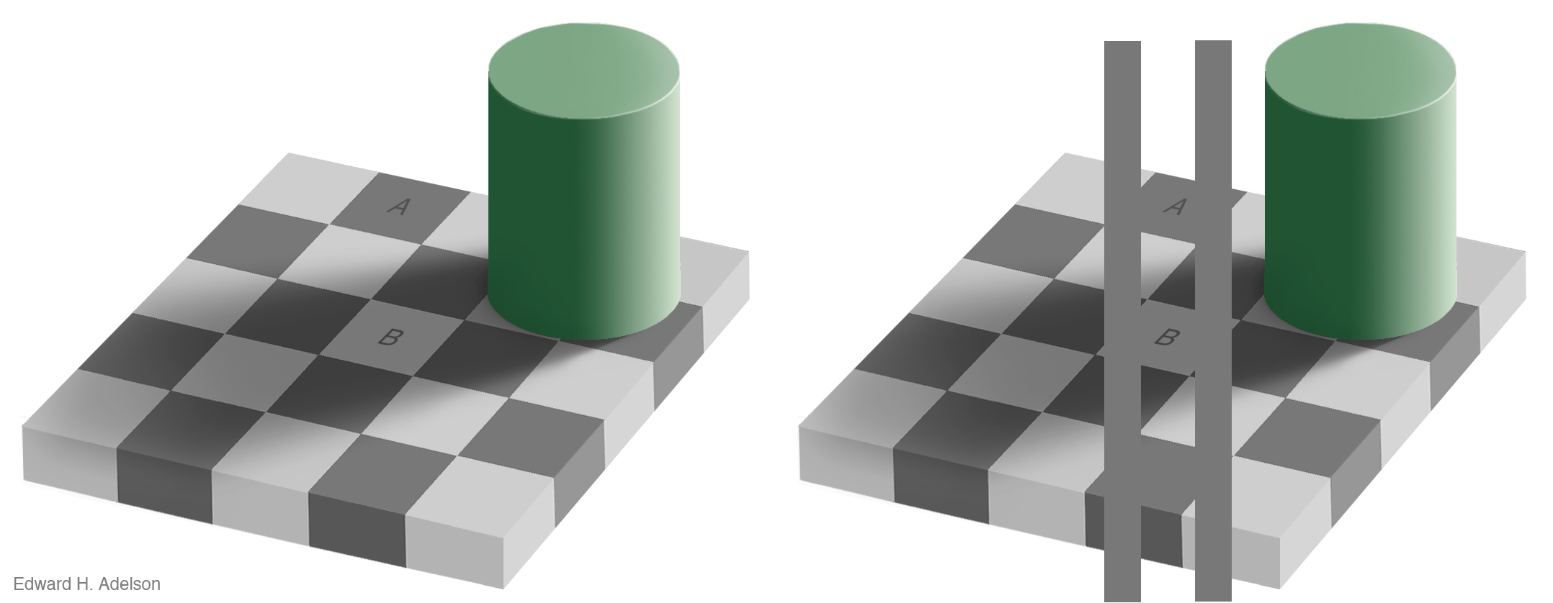
Used by permission

In the checkered square on the left, the center square is perceived as being of a shade intermediate between those of the dark and light squares surrounding it, because of the shadow cast by the pillar. Yet when it is bracketed between two columns of the same shade as the dark squares, the center square appears to be equally dark. The discrepancy between the two views is made up entirely in our own minds, as technically explained on Adelson’s website.
Optical illusions deceive us because our perceptual faculties are hardwired to see them a certain way. Similarly, as we grow up we become similarly hardwired to see things from the perspectives of the family, social, and other contexts that construct our perceptions of what is given. The arbitrary nature of such constructs is also corroborated in an interview of noetic scientist Dean Radin, who goes on to tell how these constructs can be neutralized:
Our perception of the world is our own construction. We don’t see the world the way the world actually is, we see the world the way we construct the world. Yet numerous experiments have demonstrated that the way we experience the world, both in time and in space, really is a construction, and that when you make very slight changes in your expectations of what you are going to see you will see completely different things.
Dean Radin is among those who know that causing outcomes is a science of managing our perceptions. It is a science of consciously aligning our actions to be consistent with our projected outcomes, while refusing to settle for anything other than the outcome we expect. Thus aligning what we accept with what we expect, by conforming our acceptations to our expectations, is the science that got Susan Bradford to the ER.
An additional successful application of this science was demonstrated by Tim Atkins, a father who likewise participated in our life-management training. Tim complained of an ongoing conflict with his son over the latter’s “horribly messy and dirty room.” No amount of reasoning, persuasion, or reasonable punishment had succeeded in motivating the boy to keep his room neat and clean. The resulting chronic stress in their relationship was making their relationship messy as well.
We told Tim that having his son’s room neat and clean was entirely his own expectation, which made the room’s messiness entirely his problem and not his son’s. Tim felt so affronted by this that he became quite angry, shouting, “That would mean that I have to clean my son’s room myself, and I’m certainly not going to do that!”
Still angry when he got home from the training, Tim busied himself with repairing some furniture in his garage. While he was distracted by this activity, it occurred to him that his actual problem with his son’s room was seeing the mess it was in whenever he walked by it, and not the messy room itself. As soon as this was clear to him, he thought of a solution. He removed the door from his son’s room and sawed off the lower third. He nailed the upper two-thirds into the doorway so it would be permanently closed, then remounted the doorknob in the lower third of the door so that his son could still enter and leave the room. He then explained to his son that since he would never again see the mess it wouldn’t bother him, and the room would no longer be an occasion of constant contention in their relationship.
A few days later his son came to him and said, “Dad, we’ve got to talk. When I bring friends home from school, it is so embarrassing to have to get down on our hands and knees to crawl into my room. I’ll keep my room in order if you’ll fix the door.”
Until Tim Atkins resolved his problem, he was like anyone who has an expectation that someone in his or her life doesn’t meet. He had only three choices available to him: let go of the expectation, let go of the person, or continue to fret with struggle, stress and conflict. Yet once Tim clearly owned the problem precisely as he was experiencing it, which was his having to see his son’s messy room when he walked by it rather than the messy room itself, he was empowered to adopt a workable expectation that was in alignment with his acceptation. Having thus resolved his problem entirely in his own mind, he ceased his outward projection of his formerly unworkable expectation upon his son. And as is often the case whenever we successfully exercise our faculty of allowing the outer world’s impressions to approach us only as we have determined, resolving his own relationship to “the” problem called forth his son’s resolution as well.

